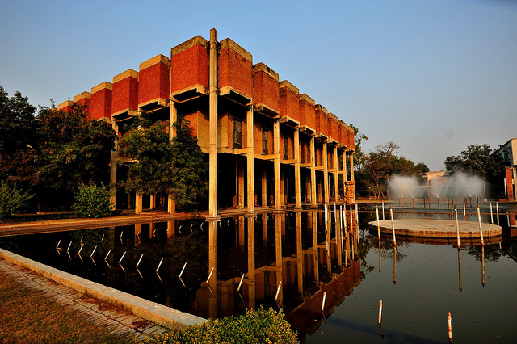

Guesstimaze ’15


Team Cognition
By

What?
Guesstimaze is an online event to find some best consulting minds where you have to make an approximate estimate to the given case without complete information. The solution could be a rough approximation or an educated guess for which no better information would be available. The challenge is to use the best possible approach to get closer to a reasonable solution. The whole purpose is to evaluate your logical, analytical, and interpretation skills. You are free to make use of any relevant data with substantial proof of validity.

Where?
Online event. Please check our FB page for Questions, Results and all relevant details https://www.facebook.com/Prabandhan.MBA.IITK?ref=bookmarks.
We shall post the same on our Twitter account also : https://twitter.com/prabandhan2015

When?
Each Friday @ 09:00 P.M.

Who?
This is open to all MBA students across the country.

How?

Try to break the problem down into logical pieces, then walk us through on your approach to the problem, and try to determine appropriate assumptions for the value of key figures in each of those pieces. Participants need to submit solution through Google form we float on every Saturday properly describing their approach to solving the problem, and an approximate answer to the question asked.

Rules and Format:
- Key Points:
1. We shall start from 28th Aug 2015 and it will continue till 25th Sep 2015
2. 1 Guesstimate every Friday @ 09:00 pm
3. Guesstimate and submission Google form will be posted on Prabandhan 2015 page @ 09 pm during event dates, so like our FACEBOOK page and stay tuned.
4. All the replies will be judged purely based on the approach to the problem, accuracy and appropriateness of the assumptions made and clarity of expression. No particular answer is correct or incorrect in the given context, so it’s your view on the problem which matters most.
- Requirements
1. Contest is open to all MBA students across the country.
2. Students can participate individually or in a team of 2.
3. Multiple registration is not allowed. One participate can be a part of one team only.
- Awards
Take part and Win!!! Grab prizes worth Rs. 1500!!!
- Timeline
Registration and Submission to be done between 09 pm Friday and 9pm Saturday. No entry will be taken afterwards.
- Announcement of Results
Results will be announced in the following week..
- For any queries, Contact:
Bala Yesu Achyuta: +919453835503
Navneet Malviya: +919198261960

