INDEX

Name of Work: Disinfection / general pest control for cockroaches, lizards, spiders, mosquito control treatment in Visitors Hostel at IIT Kanpur

Sl.No. | Description | Page
1 | Index Page | 1
2 | Notice inviting E-tenders | 2
3 | Information and e-Tendering for Contractors | 3-5
4 | Notice Inviting Tenders (Form CPWD–6) | 6-8
5 | Tender (Form CPWD–7) | 9-10
6 | Special Terms & conditions | 11-12
7 | Indemnity Bond | 13-19

NIT amounting to Rs. 1,66,560.00 (Rupees One Lac Sixty Six Thousand Five Hundred Sixty Only) is approved.

[Certified that this N.I.T. contains 19 (Nineteen) pages]

Sr. Assistant Engineer (SG) |  | Executive Engineer
I.W.D. Division-I |  | I.W.D. Division-I
I.I.T., Kanpur |  | I.I.T., Kanpur

INDIAN INSTITUTE OF TECHNOLOGY, KANPUR

INSTITUTE WORKS DEPARTMENT

CENTRAL OFFICE

Notice Inviting e-Tenders

The Executive Engineer, IWD, IIT Kanpur invites on behalf of Board of Governors of IIT Kanpur online item rate tenders from empanelled / working contractors of IIT Kanpur on single bid system for following work:-
- NIT No. 21/C/D1/2020-21/01, Name of work: Disinfection / general pest control for cockroaches, lizards, spiders, mosquito control treatment in Visitors Hostel at IIT Kanpur, Estimated cost Rs. 1,66,560/-, Earnest money Rs. 3331/-, Period 12 months, Last time and date of submission of bid 3.30 PM on 15.02.2021.

The bid forms and other details are available on website www.iitk.ac.in/iwd/tenderhall.htm, www.tenderhome.com. But the bids can only be submitted online on www.tenderwizard.com/IIT.
No. IWD/Div-I/ 573 Dated: 08.02.2021 Executive Engineer

INFORMATION AND INSTRUCTIONS FOR CONTRACTORS FOR e-TENDERING FORMING PART OF NIT AND TO BE POSTED ON WEBSITE
The Superintending Engineer, IWD, I.I.T., Kanpur on behalf of Board of Governors of IIT Kanpur invites online item rate tender from eligible and specialized agencies / contractors for the following work(s):
S. No. 1 | NIT NO. | Name of work and location | Estimated cost put to tender | Earnest Money | Period of Completion | Last date & time of submission of tender | Period during  which EMD,  Cost of Tender  Document,  e-Tender  Processing  Fee and other  Documents  shall be  submitted | Time &  date of  opening  of tender
1 | 21/C/D1/2020-21/01 | Disinfection / general pest control for cockroaches, lizards, spiders, mosquito control treatment in Visitors Hostel at IIT Kanpur | Rs. 16656/- | 3331.00 | 12 Months | Upto 3.30 PM on 15.02.2021 | upto 3:30 PM on 17.02.2021 | At 3:30 PM on 18.02.2021

*The eligible contractors having license to stock & use (Form-VI-C), License to sell (Form-VIII) of chemical, specialized in such type of works, furnish the definite proof from the appropriate authority of having satisfactorily completed three similar works of value 40% or two similar works of value 60% or one similar work of value 80% of estimated cost during last seven years.
The license registration of the agencies / contractors should be valid on the last date of submission of tenders.
In case the last date of submission of tender is extended, the enlistment / registered of contractor should be valid on the original date of submission of tenders.
- The intending tenderer must read the terms and conditions of CPWD-6 for e-Tendering carefully. He should only submit his tender if he considers himself eligible and he is in possession of all the documents required.
- Information and Instructions for tenderer posted on website shall form part of tender document.
- The bid document consisting of plans, specifications the schedule of quantities of varies types of items to be executed and set of terms and conditions of the contract to be complied with and other necessary documents can be seen and downloaded from website www.iitk.ac.in/iwd/tenderhall.htm, www.tenderhome.com and free of cost and shall be submitted on line on website www.tenderwizard.com/IIT.
- The intending tenderer has to fill all the details such as Banker's name, Demand Draft/Fixed Deposit Receipt /Pay Order/ Banker's Cheque/Bank Guarantee number, amount and date.
The amount of EMD can be paid by multiple Demand Draft / Pay Order / Banker's Cheque / Deposit at call receipt / Fixed Deposit Receipts of any Scheduled Bank.
- Those contractors not registered on the website mentioned above, are required to get registered beforehand. If needed they can be imparted training on online bidding process as per details available on the website.
- The intending tenderer must have valid class-III digital signature to submit the tender.
- On opening date, the contractor can login and see the tender opening process. After opening of tenders he will receive the competitor tender sheets.
- Contractor can upload documents in the form of JPG format and PDF format.
- Contractor must ensure to quote rate of each item. The column meant for quoting rate in figures appears in yellow colour.
In addition to this, while selecting any of the cells a warning appears that if any cell is left blank the same shall be treated as “0”.
Therefore, if any cell is left blank and no rate is quoted by the tenderer, rate of such item shall be treated as “0” (ZERO).

List of Documents to be scanned and uploaded within the period of tender submission:
- Scan copy of Certificate of Registration (ISO)

- Scan copy of Licence to stock & Use etc (Form-VI-C)

- Scan copy of Licence to Sell & Stock etc. (Form-VIII)

- Required Experience / completion certificates of similar nature of works.

- Registration Certificates of EPF and ESIC

- Scan copy of E.M.D. as to be submitted in hard copy.

- GST Registration No.

- The work is estimated to cost Rs. 1,66,560.00. This estimate, however, is given merely as a rough guide.
Criteria of eligibility
*The eligible contractors having license to stock & use (Form-VI-C), License to sell (Form-VIII) of chemical, specialized in such type of works, furnish the definite proof from the appropriate authority of having satisfactorily completed three similar works of value 40% or two similar works of value 60% or one similar work of value 80% of estimated cost during last seven years.

- Agreement shall be drawn with the successful tenderers on prescribed Form No. CPWD 7 (or other Standard Form as mentioned) which is available as a Govt. of India Publication and also available on website www.iitk.ac.in Tenderers shall quote his rates as per various terms and conditions of the said form which will form part of the agreement.

- The time allowed for carrying out the work is 12 months from the date of start as defined in schedule „F‟.

- The site for the work is available.*

- The bid document consisting of plans, specifications the schedule of quantities of varies types of items to be executed and set of terms and conditions of the contract to be complied with and other necessary documents can be seen and downloaded from website www.iitk.ac.in/iwd/tenderhall.htm, www.tenderhome.com free of cost and shall be submitted on line on website www.tenderwizard.com/IIT other necessary documents also can be seen in the office of the Executive Engineer, IWD Division-I, IIT, Kanpur between hours of 10:00 AM to 5:00 PM from 09.02.2020 to 14.02.2021 every day accept on Saturdays, Sundays and Public Holidays free of cost.

- After submission of the tender the contractor can re-submit revised tender any number of times but before last time and date of submission of tender as notified.

- While submitting the revised tender, contractor can revise the rate of one or more item(s) any number of times (he need not re-enter rate of all the items) but before last time and date of submission of tender as notified.

- Earnest Money can be paid in the form of Treasury Challan or Demand Draft or Pay order or Banker`s Cheque or Deposit at Call Receipt or Fixed Deposit
Receipt (drawn in favour of the Director, IIT, Kanpur) along with Bank Guarantee of any Scheduled Bank wherever applicable.
(i) e-Tender Processing Fee – Rs. 885/- drawn in favour of "ITI Limited" payable at Delhi in the form of e-payment. No other mode of payment can be accepted.
Treasury Challan or Demand Draft or Pay Order or Banker`s Cheque or Deposit at Call Receipt or FDR against EMD, proof of Cost of Tender Document and Cost of Tender Processing Fee shall be placed in single sealed envelope superscripted as “Earnest Money, proof of Cost of Tender Document and Cost of Tender Processing Fee” with name of work and due date of opening of the tender also mentioned thereon.
The copy of work experience wherever applicable and other documents if required and specified in this bid document shall be scanned and uploaded to the e-Tendering website within the period of tender submission and certified copy of each shall be deposited in a separate envelop marked as “Other Documents” in the divisional office upto 3.30 PM on 17.02.2021.
Both the envelopes shall be placed in another envelope with due mention of Name of work, date & time of opening of tenders and to be submitted in the office of Executive Engineer after last date & time of submission of tender and up to 03:30 PM on 17.02.2021.
Online tender documents submitted by intending tenderers shall be opened only of those tenderers, whose Earnest Money Deposit and e- Tender Processing Fee and other documents placed in the envelope are found in order.
The tender submitted shall be opened at 03:30 PM on 18.02.2021.
- The tender submitted shall become invalid & e-Tender processing fee shall not be refunded if:
- The tenderer is found ineligible.
- The tenderer does not upload all the documents as stipulated in the tender document.
- If any discrepancy is noticed between the documents as uploaded at the time of submission of tender and hard copies as submitted physically in the office of tender opening authority.
10. The contractor whose tender is accepted will be required to furnish performance guarantee of 5% (Five Percent) of the tendered amount within the period specified in Schedule. This guarantee shall be in the form of FDR. In case the contractor fails to deposit the said performance guarantee within the period as indicated in Schedule, including the extended period if any, the Earnest Money deposited by the contractor shall be forfeited automatically without any notice to the contractor.
11. The competent authority on behalf of the Board of Governors, IIT, Kanpur does not bind itself to accept the lowest or any other tender and reserves to itself the authority to reject any or all the tenders received without the assignment of any reason. All tenders in which any of the prescribed condition is not fulfilled or any condition including that of conditional rebate is put forth by the tenderers shall be summarily rejected.
12. Canvassing whether directly or indirectly, in connection with tenderers is strictly prohibited and the tenders submitted by the contractors who resort to canvassing will be liable for rejection.
13. The competent authority on behalf of Board of Governors, IIT, Kanpur reserves to himself the right of accepting the whole or any part of the tender and the tenderers shall be bound to perform the same at the rate quoted.
14. The tender for the works shall remain open for acceptance for a period of ninety (90) days from the date of opening of tenders if any tenderer withdraws his tender before the said period or issue of letter of acceptance, whichever is earlier, or makes any modifications in the terms and conditions of the tender which are not acceptable to the department, then the Government shall, without prejudice to any other right or remedy, be at liberty to forfeit 50% of the said earnest money as aforesaid. Further the tenderers shall not be allowed to participate in the retendering process of the work.
15. This Notice Inviting Tender shall form a part of the contract document. The successful tenderers/contractor, on acceptance of his tender by the Accepting Authority shall within 15 days from the stipulated date of start of the work, sign the contract consisting of:-
a) The Notice Inviting Tender, all the documents including additional conditions, specifications and drawings, if any, forming part of the tender as uploaded at the time of invitation of tender and the rates quoted online at the time of submission of tender and acceptance thereof together with any correspondence leading thereto.
b) Standard C.P.W.D. Form 7 or other Standard C.P.W.D. Form as applicable.

Superintending Engineer
For & on behalf of the Board of Governors, IIT, Kanpur
CPWD-7

(A) | Tender for the work of: | Disinfection / general pest control for cockroaches, lizards, spiders, mosquito control treatment in Visitors Hostel at IIT Kanpur
TENDER
I/We have read and examined the Notice Inviting tender, schedule, Specifications applicable, General Rules and Directions, Conditions of Contract, clauses of contract, Special conditions, Schedule of Rate & other documents and rules referred to in the conditions of contract and all other contents in the tender document for the work.
I/We hereby tender for the execution of the work specified for the Board of Governors, IIT, Kanpur within the time specified in Schedule, viz., schedule of quantities and in accordance in all respects with the specifications and instructions in writing referred to in Rule-1 of General Rules and Directions and in Clause 11 of the Conditions of contract and with such materials as are provided for, by, and in respects in accordance with, such conditions so far as applicable.
We agree to keep the tender open for (90) ninety days from the date of opening of tender and not to make any modifications in its terms and conditions.
A sum of Rs. 3331/- is hereby forwarded in the form of FDR issued by scheduled bank as earnest money. If I/we, fail to furnish the prescribed performance guarantee or fail to commence the work within prescribed period I/we agree that the said Board of Governors, IIT, Kanpur shall without prejudice to any other right or remedy be at liberty to forfeit the said earnest money absolutely. Further, if I/we fail of commence work as specified, I/we agree that Board of Governors, IIT, Kanpur shall without prejudice to any other right or remedy available in law, be at liberty to forfeit the said earnest money and the performance guarantee absolutely, otherwise the said earnest money shall be retained by him towards security deposit to execute all the works referred to in the tender documents upon the terms and conditions contained or referred to therein and to carry out such deviations as may be ordered, up to maximum of the percentage mentioned in Schedule and those in excess of that limit at the rates to be determined in accordance with the provision contained.
Further, I/We agree that in case of forfeiture of earnest money or both Earnest Money & Performance Guarantee as aforesaid, I/We shall be debarred for participation in the re-tendering process of the work.
I/We undertake and confirm that eligible similar work(s) has/ have not been got executed through another contractor on back to back basis. Further that, if such a violation comes to the notice of Department, then I/we shall be debarred for tendering in IIT, Kanpur in future forever. Also, if such a violation comes to the notice of Department before date of start of work, the Engineer-in-Charge shall be free to forfeit the entire amount of Earnest Money Deposit/Performance Guarantee.
I/We hereby declare that I/we shall treat the tender documents drawings and other records connected with the work as secret/confidential documents and shall not communicate information derived therefrom to any person other than a person to whom I/we am/are authorized to communicate the same or use the information in any manner prejudicial to the safety of the State.

**
Dated ______**_________ Signature of contractor
Postal Address **
Witness: **
Address: **
Occupation: **

SPECIAL TERMS AND CONDITIONS

- The hard copies should be enclosed in a properly sealed envelope addressed to the Executive Engineer, Division-I, IWD, IIT Kanpur- 208016. Tender No. and date of submission and date of opening should invariably be given on the envelope.

- The rate quoted should be F.O.R. IIT Kanpur including spreading, injecting in designated area / houses / labs and whichever area as instructed by the Engineer-In-Charge.

- The rate quoted should be without GST.

- The GST as applicable shall be paid separately along with the bills.

- The firms are requested to upload scan copy of detailed description & specifications of the chemical quoted. The name of the brand / make should also in variably be stated. In absence of these particulars the tenders are liable for rejection.

- The bill shall be prepared only after obtaining satisfactory work completion certificate from the users.

- According to standard terms, full payment will be made within 30 days after satisfactory completion, checking & verification by the concerned Engineer.

- A penalty @ Rs. 200/- per day shall be charged if required work not completed within stipulated date of completion.

- The tenderer shall be required to deposit Earnest Money of Rs. 9,656/- in the form of FDR in favour of the Director, IIT, Kanpur alongwith the documents and scan copy of the same may be uploaded. The FDR shall be released after one year from the date of completion of the agreement.

- The lowest tenderer shall be required to deposit Performance Guarantee @5% of the tender cost and Security Money @3% of the tender cost in the form of FDR in favour of the Director, IIT, Kanpur.

- The Institute reserve the right to reject all or any of the tenders and to split up the requirements or relax any or all of the above conditions without assigning any reasons.

- The contractor has to brought the chemical in sealed packed drum & deposit in the custody of the concerned Engineer(s) after getting testing of same the material may only be allowed to use.

- The contractor has to deploy one skilled, one technical supervisor in the Institute who should be available on a phone call from the department. The contractor has to provide local address & contact nos.

- The work shall be executed in piece works basis as whenever required by the users / residents throughout a year.

- The contractor has to submit a guarantee bond of 5 years on the stamp paper duly Notarized & total 10% of the value of the work done shall be kept on hold & the same shall be released after 5 years.

Executive Engineer

To be signed by the bidder and same signatory competent / authorized to sign the relevant contract on behalf of IIT Kanpur.

INTEGRITY AGREEMENT

This integrity Agreement is made at _________ on this ________ day of 2021.
BETWEEN

The Director IIT Kanpur represented through Superintending Engineer, IWD, IIT Kanpur (hereinafter referred as the Principal / Owner, which expression shall unless repugnant to the meaning or context hereof include its successors and permitted assigns)

AND

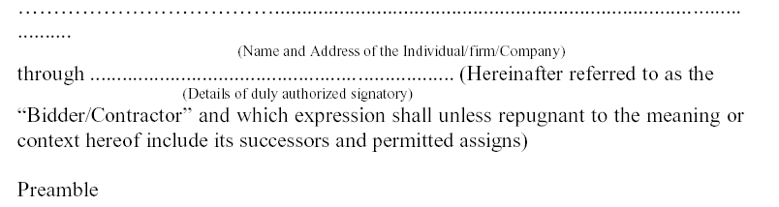

WHEREAS the Principal /Owner has floated the Tender (NIT No. 21/C/D1/2020-21/01) (hereafter referred to as “Tender / Bid”) and intends to award, under laid down organization procedure, contract for “Disinfection / general pest control for cockroaches, lizards, spiders, mosquito control treatment in Visitors Hostel at IIT Kanpur”

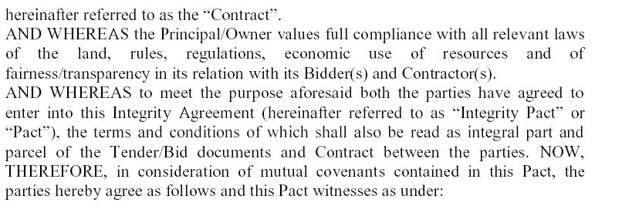
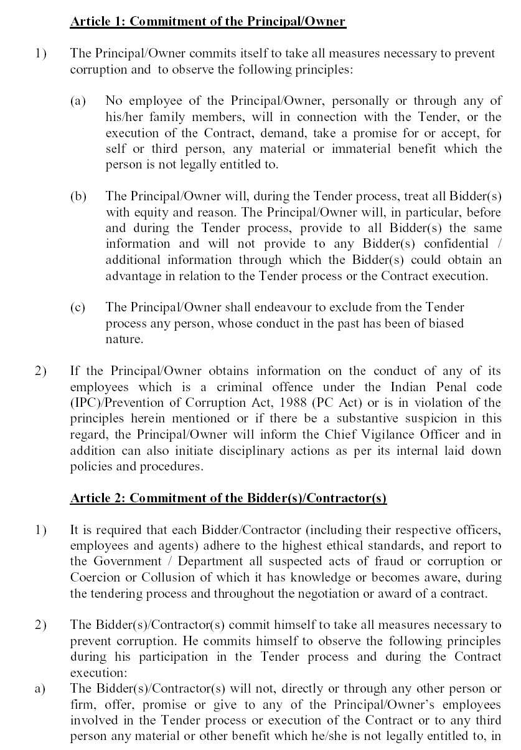
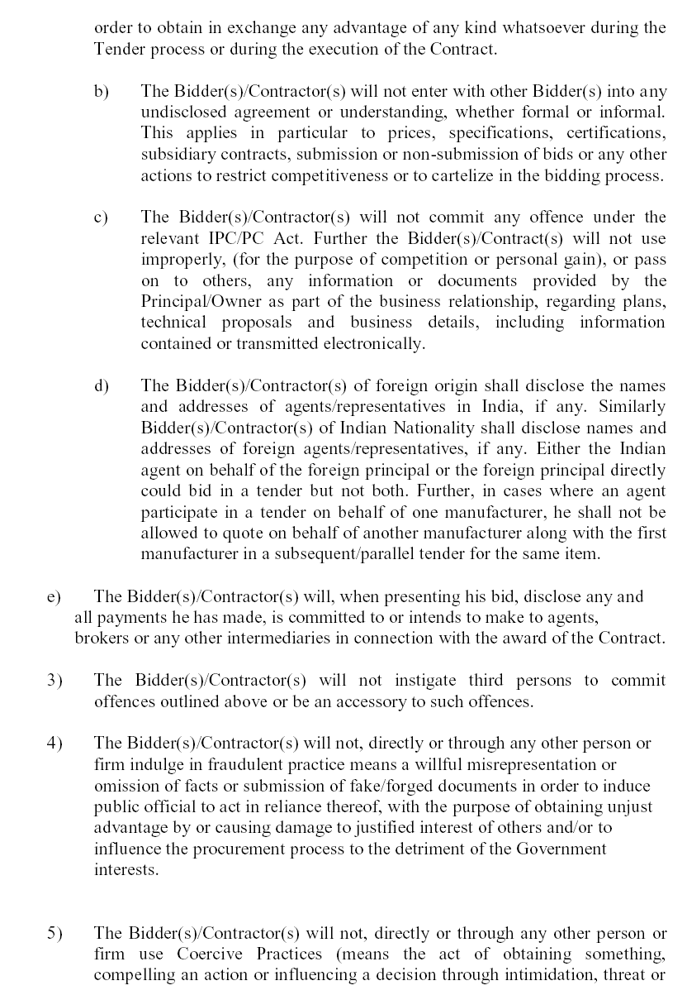

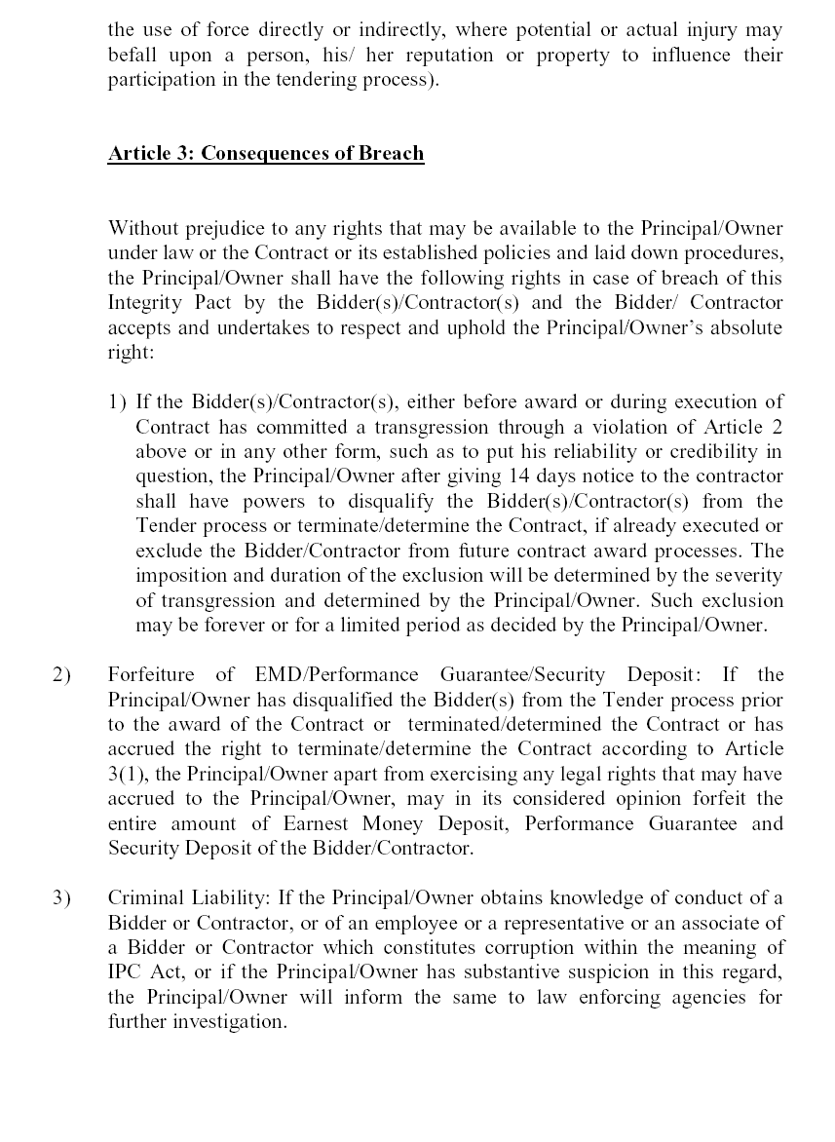

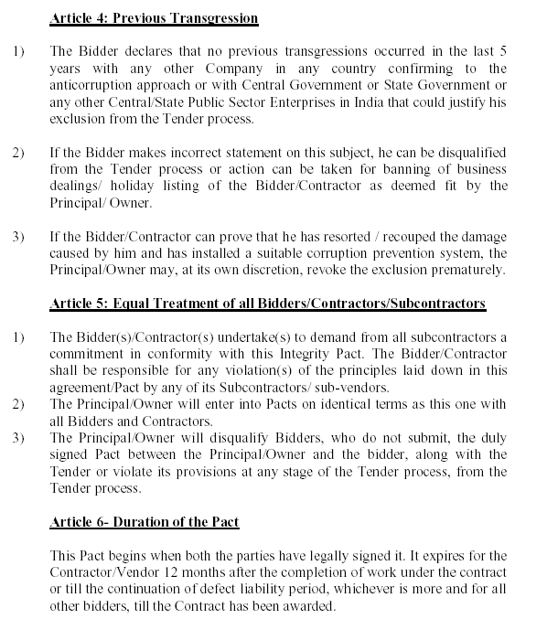

If any claim is made / lodged during the time, the same shall be binding and continue to be valid despite the lapse of this Pacts as specified above, unless it is discharged / determined by the Competent Authority, IIT Kanpur.

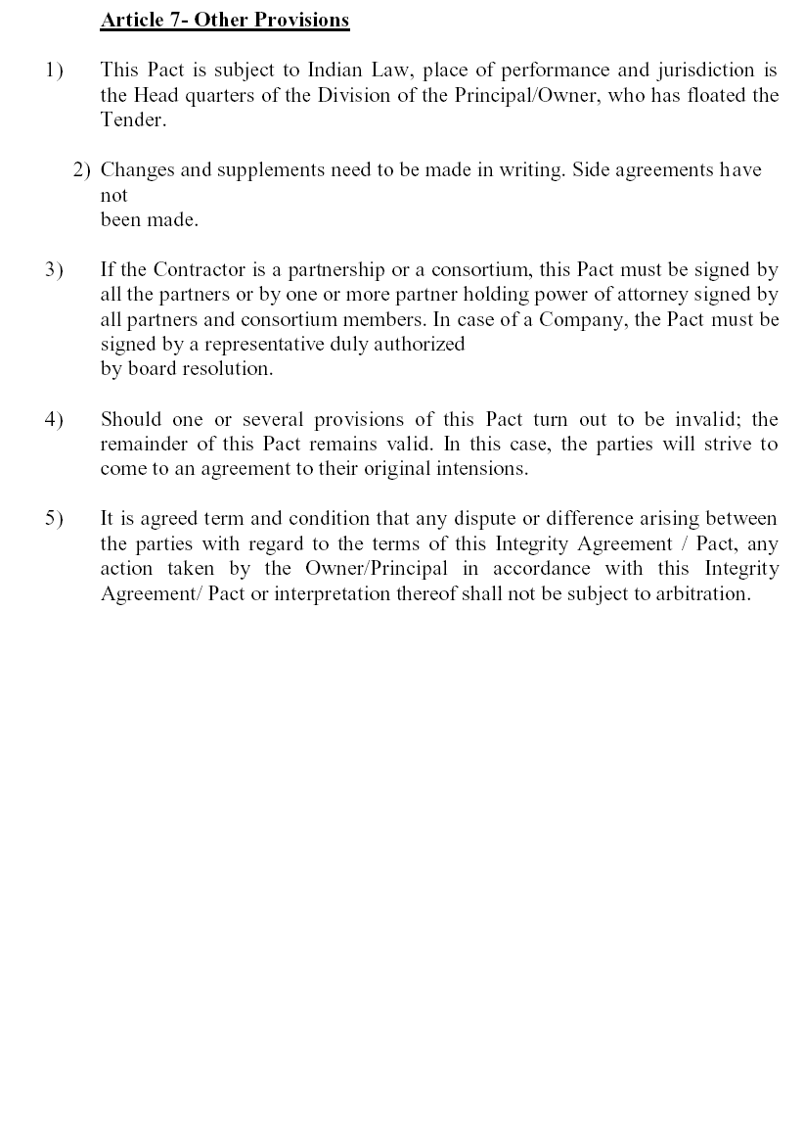

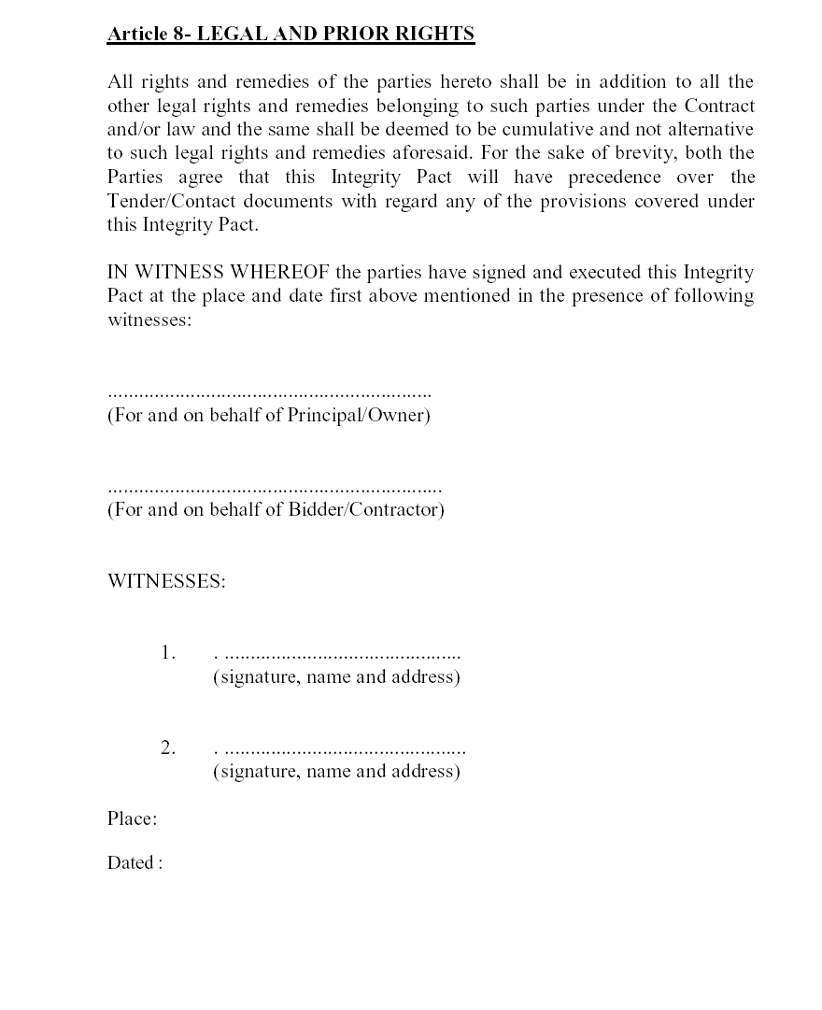

(Indicate the name of the Bank)

