INDEX

Name of Work: Day to day maintenance of building in academic area Zone -II .

Sl.No. | Description | Page
1 | Index Page | 1
2 | Notice inviting E-tenders | 2
3 | PART-A | 3
4 | Information and e-Tendering for Contractors | 4-7
5 | Notice Inviting Tenders (Form CPWD–6) | 8-12
6 | Tender (Form CPWD–7/8) | 13-18
7 | Salient/Mandatory requirement for tender | 19
8 | PART-B | 20
9 | Special conditions | 21-25
10 | Scope of Work | 26-29
11 | Special Condition for Safety at work site | 30-31
12 | Undertaking from the Tenderer | 32
13 | Indemnity Bond | 33-40
14 | Performance Security Guarantee bond | 41-43
15 | Form of Earnest money (Bank Guarantee) | 44-45

NIT amounting to Rs. 40,33,404/- (Rupees Forty Lac Thirty Three Thousand Four Hundred Four Only) is approved.

[Certified that this N.I.T. contains 44 (Forty Four) pages + BOQ contains 01 page Total 45 pages only].

Assistant Engineer |  | Executive Engineer
I.W.D. Division-II |  | I.W.D. Division-II
I.I.T., Kanpur |  | I.I.T., Kanpur

INDIAN INSTITUTE OF TECHNOLOGY KANPUR
INSTITUTE WORKS DEPARTMENT
CENTRAL OFFICE
Notice Inviting e-Tenders No. 34/Civil/D2/2019-20

The Acting Superintending Engineer, IWD, IIT Kanpur invites on behalf of Board of Governors of IIT Kanpur online item rate tenders on single bid system for following work(s):-

- NIT No. 34/Civil/D2/2019-20/01, Name of work: Day to day maintenance of building in academic area Zone -II , Estimated cost Rs. 40,33,404/-, Earnest money Rs. 80,668/-, Period of completion 12 Months, Last time & dated of submission of bid 3.30PM on 20.01.2020.

The bid forms and other details are available on website www.iitk.ac.in/iwd/tenderhall.htm,www.eprocure.gov.in/cppp/latestactivetenders,www.tenderhome.com. But the bids can only be submitted online on www.tenderwizard.com/IIT.

No. IWD/DIV-II/2020/ Dated: Superintending Engineer

INFORMATION AND INSTRUCTIONS FOR CONTRACTORS FOR e-TENDERING FORMING PART OF NIT AND TO BE POSTED ON WEBSITE
The Acting Superintending Engineer, IWD, I.I.T., Kanpur on behalf of Board of Governors of IIT Kanpur invites online item rate tender from approved and eligible* contractors for the following work(s):
S. No. | NIT NO. 34/Civil/D2/2019-20/01 | Name of work and location | Estimated cost put to tender | Earnest Money | Period of Completion | Last date & time of submission of tender | Period during  which EMD,  Cost of Tender  Document,  e-Tender  Processing  Fee and other  Documents  shall be  submitted | Time &  date of  opening  of tender
1 | NIT NO. 34/Civil/D2/2019-20/01 | Day to day maintenance of building in academic area Zone -II . | Rs. 40,33,404.00 | 80,668.00 | 12 Months | Upto 3:30 PM on 20-01-2020 | After last date and time of submission of tender and upto 3:30 PM on 21-01-2020 | At 3:30 PM on 22-01-2020

*The eligible contractors means registered in CPWD, BSNL, MES, Railways, Central PSUs & working contractors of IIT Kanpur if they furnish the definite proof from the appropriate authority of having satisfactorily completed three similar works of value 40% or two similar works of value 60% or one similar work of value 80% of estimated cost during last five years.

The enlistment / registration of the contractors should be valid on the last date of submission of tenders.
In case the last date of submission of tender is extended, the enlistment / registered of contractor should be valid on the original date of submission of tenders.
- The intending tenderer must read the terms and conditions of CPWD-6 for e-Tendering carefully. He should only submit his tender if he considers himself eligible and he is in possession of all the documents required.
- Information and Instructions for tenderer posted on website shall form part of tender document.
- The tender document consisting of plans, specifications, the schedule of quantities of various types of items to be executed and the set of terms and conditions of the contract to be complied with and other necessary documents can be seen and downloaded from website www.iitk.ac.in/iwd/tenderhall.htm or www.tenderwizard.com/IIT or www.eprocure.gov.in/cppp/latestactivetenders, www.tenderhome.com, free of cost.
- The tender can only be submitted after uploading the mandatory scanned documents as per list given below.
- The intending tenderer has to fill all the details such as Banker's name, Demand Draft/Fixed Deposit Receipt /Pay Order/ Banker's Cheque/Bank Guarantee number, amount and date.
The amount of EMD can be paid by multiple Demand Draft / Pay Order / Banker's Cheque / Deposit at call receipt / Fixed Deposit Receipts along with multiple Bank Guarantee of any Scheduled Bank if EMD is also acceptable in the form of Bank Guarantee.
- Those contractors not registered on the website mentioned above, are required to get registered beforehand. If needed they can be imparted training on online bidding process as per details available on the website.
- The intending tenderer must have valid class-III digital signature to submit the tender.
- On opening date, the contractor can login and see the tender opening process. After opening of tenders he will receive the competitor tender sheets.
- Contractor can upload documents in the form of JPG format and PDF format.

- Contractor must ensure to quote rate of each item excluding EPF & ESIC contribution. The column meant for quoting rate in figures appears in pink colour and the moment rate is entered, it turns sky blue.
In addition to this, while selecting any of the cells a warning appears that if any cell is left blank the same shall be treated as “0”.
Therefore, if any cell is left blank and no rate is quoted by the tenderer, rate of such item shall be treated as “0” (ZERO).

List of Documents to be scanned and uploaded within the period of tender submission:
- Copy of Registration with the Department.
- Required Experience / completion certificates of similar nature of works.
- Certificates of EPF & ESIC.
- Proof of cost of e-tender document & processing fee.
- Registration Certificates of GST No.
CPWD-6 FORM e-Tendering
1.1 The work is estimated to cost Rs. 40,33,404/- This estimate, however, is given merely as a rough guide.
The Superintending Engineer, IWD, I.I.T., Kanpur on behalf of Board of Governors of IIT Kanpur invites online item rate tenders from approved and eligible* contractors for the works of: Day to day maintenance of building in academic area Zone -II .

1.2 The authority competent to approve NIT for the combined cost and belonging to the major discipline will consolidate NITs for calling the tenders. He will also nominate Division which will deal with all matters relating to the invitation of tenders.
2 Criteria of eligibility
*The eligible contractors means registered in CPWD, BSNL, MES, Railways, Central PSUs & working contractors of IIT Kanpur if they furnish the definite proof from the appropriate authority of having satisfactorily completed three similar works of value 40% or two similar works of value 60% or one similar work of value 80% of estimated cost during last five years.

3. Agreement shall be drawn with the successful tenderers on prescribed Form No. CPWD 7 (or other Standard Form as mentioned) which is available as a Govt. of India Publication and also available on website www.iitk.ac.in Tenderers shall quote his rates as per various terms and conditions of the said form which will form part of the agreement.
4. The time allowed for carrying out the work will be 12 Months from the date of start as defined in schedule ‘F’ or from the first date of handing over of the site, whichever is later, in accordance with the phasing, if any, indicated in the tender documents.
5. The site for the work is available.*
6. The tender document consisting of plans, specifications, the schedule of quantities of various types of items to be executed and the set of terms and conditions of the contract to be complied with and other necessary documents except Standard General Conditions of Contract Form can be seen on website www.iitk.ac.in/iwd/tenderhall.htm or www.tenderwizard.com/IIT or www.tenderhome.com, www.eprocure.gov.in/cppp/latestactivetenders other necessary documents also can be seen in the office of the Executive Engineer, IWD Division-II, IIT, Kanpur between hours of 10:00 AM to 5:00 PM from 10-01-2020 to 20-01-2020 every day accept on Saturdays, Sundays and Public Holidays in free of cost.
7. After submission of the tender the contractor can re-submit revised tender any number of times but before last time and date of submission of tender as notified.
8. While submitting the revised tender, contractor can revise the rate of one or more item(s) any number of times (he need not re-enter rate of all the items) but before last time and date of submission of tender as notified.
9. When tenders are invited in three stage system and if it is desired to submit revised financial tender then it shall be mandatory to submit revised financial tender. If not submitted then the tender submitted earlier shall become invalid.
10. Earnest Money can be paid in the form of Treasury Challan or Demand Draft or Pay order or Banker`s Cheque or Deposit at Call Receipt or Fixed Deposit
Receipt (drawn in favour of Director, IIT, Kanpur along with Bank Guarantee of any Scheduled Bank wherever applicable.
A part of earnest money is acceptable in the form of bank guarantee also. In such case, 50% of earnest money or Rs. 20 lac, whichever is less, will have to be deposited in shape prescribed above, and balance in shape of Bank Guarantee of any scheduled bank.
e-Tender Processing Fee – Rs. 4,759/- drawn in favour of "ITI Limited" payable at Delhi through e-payment. No other mode of payment is acceptable.
Treasury Challan or Demand Draft or Pay Order or Banker`s Cheque or Deposit at Call Receipt or FDR or Bank Guarantee against EMD, Cost of Tender Document and Cost of Tender Processing Fee shall be placed in single sealed envelope superscripted as “Earnest Money, Cost of Tender Document and Cost of Tender Processing Fee” with name of work and due date of opening of the tender also mentioned thereon.
Copy of Enlistment Order and certificate of work experience wherever applicable and other documents if required and specified in this bid document shall be scanned and uploaded to the e-Tendering website within the period of tender submission and certified copy of each shall be deposited in a separate envelop marked as “Other Documents” in the divisional office up to 3.30 PM on 21-01-2020.

Both the envelopes shall be placed in another envelope with due mention of Name of work, date & time of opening of tenders and to be submitted in the office of Executive Engineer after last date & time of submission of tender and up to 03:30 PM on 21-01-2020.
Online tender documents submitted by intending tenderers shall be opened only of those tenderers, whose Earnest Money Deposit, Cost of Tender Document and e- Tender Processing Fee and other documents placed in the envelope are found in order.
The tender submitted shall be opened at 03:30 PM on 22-01-2020.
11. The tender submitted shall become invalid and cost of tender & e-Tender processing fee shall not be refunded if:
- The tenderers is found ineligible.
- The tenderers does not upload all the documents as stipulated in the tender document.
- If any discrepancy is noticed between the documents as uploaded at the time of submission of tender and hard copies as submitted physically in the office of tender opening authority.
12. The contractor whose tender is accepted will be required to furnish performance guarantee of 5% (Five Percent) of the tendered amount within the period specified in Schedule F. This guarantee shall be Deposit at Call receipt of any scheduled bank / Banker’s cheque of any scheduled bank / Demand Draft of any scheduled bank / Pay order of any Scheduled Bank of any scheduled bank or Government Securities or Fixed Deposit Receipts or Guarantee Bonds of any Scheduled Bank or the State Bank of India in accordance with the prescribed form. In case the contractor fails to deposit the said performance guarantee within the period as indicated in Schedule ‘F’, including the extended period if any, the Earnest Money deposited by the contractor shall be forfeited automatically without any notice to the contractor.
13. Intending Tenderers are advised to inspect and examine the site and its surroundings and satisfy themselves before submitting their tenders as to the nature of the ground and sub-soil (so far as is practicable), the form and nature of the site, the means of access to the site, the accommodation they may require and in general shall themselves obtain all necessary information as to risks, contingencies and other circumstances which may influence or affect their tender. A tenderers shall be deemed to have full knowledge of the site whether he inspects it or not and no extra charge consequent on any misunderstanding or otherwise shall be allowed. The tenderers shall be responsible for arranging and maintaining at his own cost all materials, tools & plants, water, electricity access, facilities for workers and all other services required for executing the work unless otherwise specifically provided for in the contract documents. Submission of a tender by a tenderers implies that he has read this notice and all other contract documents and has made himself aware of the scope and specifications of the work and local conditions and other factors having a bearing on the execution of the work.
14. The competent authority on behalf of the Board of Governors, IIT, Kanpur does not bind itself to accept the lowest or any other tender and reserves to itself the authority to reject any or all the tenders received without the assignment of any reason. All tenders in which any of the prescribed condition is not fulfilled or any condition including that of conditional rebate is put forth by the tenderers shall be summarily rejected.
15. Canvassing whether directly or indirectly, in connection with tenderers is strictly prohibited and the tenders submitted by the contractors who resort to canvassing will be liable for rejection.
16. The competent authority on behalf of Board of Governors, IIT, Kanpur reserves to himself the right of accepting the whole or any part of the tender and the tenderers shall be bound to perform the same at the rate quoted.
17. The contractor shall not be permitted to tender for works in the IIT Kanpur responsible for award and execution of contracts, in which his near relative is posted a Divisional Accountant or as an officer in any capacity between the grades of Superintending Engineer and Junior Engineer (both inclusive). He shall also intimate the names of persons who are working with him in any capacity or are subsequently employed by him and who are near relatives to any gazetted officer in the IIT Kanpur. Any breach of this condition by the contractor would render him liable to be removed from the approved list of contractors of this Department.
18. No Engineer of Gazetted Rank or other Gazetted Officer employed in Engineering or Administrative duties in an Engineering Department of the Government of India is allowed to work as a contractor for a period of one year after his retirement from Government service, without the prior permission of the Government of India in writing. This contract is liable to be cancelled if either the contractor or any of his employees is found any time to be such a person who had not obtained the permission of the Government of India as aforesaid before submission of the tender or engagement in the contractor’s service.
19. The tender for the works shall remain open for acceptance for a period of ninety (90) days from the date of opening of tenders if any tenderer withdraws his tender before the said period or issue of letter of acceptance, whichever is earlier, or makes any modifications in the terms and conditions of the tender which are not acceptable to the department, then the Government shall, without prejudice to any other right or remedy, be at liberty to forfeit 50% of the said earnest money as aforesaid. Further the tenderers shall not be allowed to participate in the retendering process of the work.
20. This Notice Inviting Tender shall form a part of the contract document. The successful tenderers/contractor, on acceptance of his tender by the Accepting Authority shall within 15 days from the stipulated date of start of the work, sign the contract consisting of:-
a) The Notice Inviting Tender, all the documents including additional conditions, specifications and drawings, if any, forming part of the tender as uploaded at the time of invitation of tender and the rates quoted online at the time of submission of tender and acceptance thereof together with any correspondence leading thereto.
b) Standard C.P.W.D. Form 7 or other Standard C.P.W.D. Form as applicable.

    - The tender document will include following three components:
Part A:-
CPWD-6, CPWD-7 including schedule A to F for the major component of the work, Standard General Conditions of Contract for CPWD 2010 as amended/modified up to 20-01-2020.
Part B:-
General/specific conditions, specifications and schedule of quantities applicable to major component of the work.
Part C:-
Schedule A to F for minor component of the work. (SE/EE in charge of major component shall also be competent authority under clause 2 and clause 5 as mentioned in schedule A to F for major components), General/specific conditions, specifications and schedule of quantities applicable to minor component(s) of the work.
    - The tenderers must associate himself, with agencies of the appropriate class eligible to tender for each of the minor component individually.
    - The eligible tenderers shall quote rates for all items of major component as well as for all items of minor components of work.
    - Entire work under the scope of composite tender including major and all minor components shall be executed under one agreement.
    - Security Deposit will be worked out separately for each component corresponding to the estimated cost of the respective component of works. The Earnest Money will become part of the security deposit of the major components of work.

Executive Engineer
For & on behalf of the Board of Governors, IIT, Kanpur
CPWD-7/8

(A) | Tender for the work of: | Day to day maintenance of building in academic area Zone -II.
Signature of officer issuing the documents ____________________________
Designation: Executive Engineer, IWD Division-II, IIT, Kanpur
Date of Issue ______________________

TENDER
I/We have read and examined the Notice Inviting tender, schedule, A,B,C,D,E&F. Specifications applicable, Drawings & Designs, General Rules and Directions, Conditions of Contract, clauses of contract, Special conditions, Schedule of Rate & other documents and rules referred to in the conditions of contract and all other contents in the tender document for the work.
I/We hereby tender for the execution of the work specified for the Board of Governors, IIT, Kanpur within the time specified in Schedule ‘F’, viz., schedule of quantities and in accordance in all respects with the specifications, designs, drawings and instructions in writing referred to in Rule-1 of General Rules and Directions and in Clause 11 of the Conditions of contract and with such materials as are provided for, by, and in respects in accordance with, such conditions so far as applicable.
We agree to keep the tender open for (90) ninety days from the date of opening of tender and not to make any modifications in its terms and conditions.
A sum of Rs. 80,668/- is hereby forwarded in Cash/Receipt Treasury Challan/Deposit at call Receipt of a Scheduled Bank/Fixed deposit receipt of scheduled bank/demand draft of a scheduled bank/bank guarantee issued by scheduled bank as earnest money. If I/we, fail to furnish the prescribed performance guarantee or fail to commence the work within prescribed period I/we agree that the said Board of Governors, IIT, Kanpur or his successors in office shall without prejudice to any other right or remedy be at liberty to forfeit the said earnest money absolutely. Further, if I/we fail of commence work as specified, I/we agree that Board of Governors, IIT, Kanpur or his successors in office shall without prejudice to any other right or remedy available in law, be at liberty to forfeit the said earnest money and the performance guarantee absolutely, otherwise the said earnest money shall be retained by him towards security deposit to execute all the works referred to in the tender documents upon the terms and conditions contained or referred to therein and to carry out such deviations as may be ordered, up to maximum of the percentage mentioned in Schedule ‘F’ and those in excess of that limit at the rates to be determined in accordance with the provision contained in Clause 12.2 and 12.3 of the tender form.
Further, I/We agree that in case of forfeiture of earnest money or both Earnest Money & Performance Guarantee as aforesaid, I/We shall be debarred for participation in the re-tendering process of the work.
I/We undertake and confirm that eligible similar work(s) has/ have not been got executed through another contractor on back to back basis. Further that, if such a violation comes to the notice of Department, then I/we shall be debarred for tendering in IIT, Kanpur in future forever. Also, if such a violation comes to the notice of Department before date of start of work, the Engineer-in-Charge shall be free to forfeit the entire amount of Earnest Money Deposit/Performance Guarantee.
I/We hereby declare that I/we shall treat the tender documents drawings and other records connected with the work as secret/confidential documents and shall not communicate information derived therefrom to any person other than a person to whom I/we am/are authorized to communicate the same or use the information in any manner prejudicial to the safety of the State.

**
Dated ______**_________ Signature of contractor
Postal Address **
Witness: **
Address: **
Occupation: **

Operative schedules shall be supplied separately to each intending tenderer)

SCHEDULE ‘A’
Schedule of Quantities: Page 1 of 1
SCHEDULE ‘B’
Schedule of materials to be issued to the contractor:
S. No. | Description of item | Quantity | Rates in figures & words at which the material will be charged to the contractor | Place of issue
1 | 2 | 3 | 4 | 5

--------------NIL ----------------
SCHEDULE ‘C’
Schedule of Tools and Plants to be hired to the contractor
S. No. | Description | Hire charges per day | Place of issue
1 | 2 | 3 | 4
--------------NIL ----------------

SCHEDULE ‘D’
Extra schedule for specific requirements/document for the work, if any: | As attached in tender form.
SCHEDULE ‘E’
Schedule of component of other Materials, Labour, POL etc. for price escalation : N.A.
SCHEDULE ‘F’
Reference to General Conditions of contract.
Name of Work: | Day to day maintenance of building in academic area Zone -II .
Estimated cost of the work: | Civil Items of Work | Rs. 40,33,404.00
Earnest money | Rs. 80,668.00
Performance Guarantee | 5% of the tendered value of the work
Security Deposit | 5% of the tendered value of the work
General rules and direction:
Officer inviting tender | Superintending Engineer,  Institute Works Department  IIT, Kanpur
Maximum percentage of quantity of items of work to be executed beyond which rates are to be determined in accordance with Clause 12.2.& 12.3 | See at appropriate clause under definitions
Definitions:
2(v) |  | Engineer-in-Charge
 |  | For Civil items of work |  |  |  | Executive Engineer,  Institute Works Department  IIT, Kanpur
2(vi) |  | Accepting Authority |  |  |  | Superintending Engineer,  Institute Works Department  IIT, Kanpur
2(vii) |  | Percentage on cost of materials and labour to cover all overheads and profits |  |  |  | 10%
2(viii) |  | Standard Schedule of Rates:
 |  | Civil Items of Work: |  | D.S.R. 2018 with up to date correction slips
2(ix) | Department: |  |  |  | Central Public Works Department
2(x) | Standard CPWD contract Form: |  |  |  | GCC 2014, CPWD form-7/8 as modified & corrected up to 31-12-2018(Whether correction vide latest circulars are incorporated or not in this document).
Clause 1 |  |  | - Time allowed for submission of Performance Guarantee from the date of issue of letter of acceptance  - Maximum allowable extension with late fee @0.1% per day of performance |  |  |  | 15 Days  01 to 15 Days
Clause 2 |  |  | Authority for fixing Compensation under Clause 2 |  |  |  | Superintending Engineer,  Institute Works Department  IIT, Kanpur.  Or successor thereof
Clause 2 A |  |  | Whether Clause 2A shall be applicable |  |  |  | No
Clause 5 |  |  | - Number of days from the date of issue of letter of acceptance for reckoning date of start |  |  |  | 22 Days
 |  |  | - Time allowed for execution of work |  |  |  | 12 (Twelve) Months

Authority to decide |  | Extension of time |  | Superintending Engineer,  Institute Works Department  IIT, Kanpur
Clause 6/ 6A |  |  |  |  |  | Only clause 6 applicable.
Clause 7 | Gross work to be done together with net payment/Adjustment of advances for material collected, if any, since the last such payment for being eligible to interim payment |  |  |  |  | Not Applicable
Clause 10A | Material to be provided by the contractor. |  |  |  |  | Applicable
Clause 10B (ii), (iii) | Whether clause 10-B (ii) and 10-B (iii) shall be applicable. |  |  |  |  | Not Applicable
Clause 10 C | Component of labour expressed as percentage of value of work |  |  |  |  | NIL
Clause 10 CA | Materials covered under this clause. |  | Nearest material(other than cement, reinforcement bars and structural steel) for which All India Whole sale price Index is to be followed. |  |  | Base price of all the materials covered under clause 10 CA
 | 1. Cement (PPC)  2. Steel |  | Nil  Nil |  |  | NIL  NIL
Clause 10 CC | Increase/Decrease in Price of materials/wages |  |  |  |  | Not Applicable
Clause 11 | Specification to be followed for execution of work:
For Civil items of work | CPWD Specifications 2009 Vol. 1 and Vol. 2 with up to date correction slips.(Hereinafter called CPWD specifications also)
Clause 12
12.2 & 12.3 | Deviation limit beyond which clause 12.2 & 12.3 shall apply for building  work |  |  |  | Not Applicable
12.5 | Deviation limit beyond which clause 12.2 & 12.3 shall apply for foundation work |  |  |  | Not Applicable

Clause 16 | Competent Authority for Deciding reduced rates:
 | For Civil items of work | Superintending Engineer,  Institute Works Department  IIT, Kanpur
Clause 18 | List of mandatory machinery, tools & plants to be deployed by the contractor at site. | N.A.
Clause 36 (i) |  | Requirement of technical Representative(s)
For supervision of civil as well as electrical items of work, technical representatives of the respective disciplines will be required to be deployed.
Clause |  | 42
i) | a) | Schedule/ statement for determining theoretical quantity of cement & bitumen on the basis of Delhi Schedule of Rates 2007 printed by CPWD | Not Applicable
ii) |  | Variations permissible on theoretical quantities
 | a) | Cement for works with estimated cost put to tender not more than Rs. 5 lakhs.
 |  | For works with estimated cost put to Tender is more than Rs. 5 lakhs
 | b) | Bitumen all works
 | c) | Steel reinforcement and structural steel Sections for diameter, section and category.
 | d) | All other materials
RECOVERY RATES FOR QUANTITIES BEYOND PERMISSIBLE VARIATION
Sl No | Description of items | Rates in figures and words at which recovery shall be made from the contractor
Sl No | Description of items | Excess beyond permissible variation | Less use beyond the permissible variation
1. | Cement (PPC) | N. A | Not Applicable
2. | Steel reinforcement (TMT Bars) | N. A | Not Applicable

Name of Work: | Day to day maintenance of building in academic area Zone -II .
- The tenderer is advised to read and examine the tender documents for the work and the set of drawings available with Engineer-in-charge. He should inspect and examine the site and its surroundings by himself before submitting his tender.
- Separate schedule of quantity is included in this tender for civil and electrical items of work. If the tenderer wants to offer any unconditional rebates on their rates, the same should also be offered in the respective components of civil and electrical schedule separately. The contractor shall quote the item rates in figures and words accurately so that there is no discrepancy in rates written in figures and words.
- Time allowed for the execution of work is 12 (Twelve) Months.
- Quality of the project is of utmost importance. This shall be adhered to in accordance with the provisions of CPWD specifications and guidelines given in the relevant paras.
- Contractor has to deploy required Plant and machinery on the project. In case the contractor fails to deploy the plant and machinery whenever required and as per the direction of the Engineer-in-charge, he (Engineer-in-charge) shall be at a liberty to get the same deployed at the risk and cost of the contractor.
- The contractor shall comply with the provisions of the Apprentices Act 1961, and the rules and orders issued there under from time to time. If he fails to do so, his failure will be a breach of the contract and the Superintending Engineer/Executive Engineer may in his discretion, without prejudice to any other right or remedy available in law, cancel the contract. The contractor shall also be liable for any pecuniary liability arising on account of any violation by him of the provisions of the said Act.

- Temporary Electric connection shall be issued as per request and the water charges shall be recovered as per rule.

SPECIAL CONDITIONS

- The Contract is for Day to day maintenance of building in academic area Zone -II .

The contract shall be drawn initially for a period of 12 (Twelve) Months. However the institute reserves the right to terminate and completely extinguish the service contract within this period from the date of commissioning. It will however issue 1 (one) month advance notice in writing of its intention to do so. The Institute reserves the right to appoint another agency for service contract from the date of termination of contract.

- Similarly the contractor shall be at liberty to seek termination of contract after the expiry of 1 (one) month from the date of commencement of the contract. It will however issue 1 (one) month advance notice in writing of its intention to do so.

- The EMD of Rs. 80,668.00 (Rupees Eighty Thousand Six Hundred Sixty Eight Only) in respect of the successful bidder will be Converted into Security Deposit and shall be held by the Institute. The deposit shall be refunded within 6 (six) months from the date of completion of contract, without any interest. In the event of failure to provide satisfactory performance, the security deposit shall be absolutely forfeited.

- The contractor shall appoint a Technical Supervisor (Minimum Qualification Diploma in Civil Engineering) for allocation of duty to the workers and for monitoring the works. He should be an experienced person with full knowledge of Construction and Maintenance works.

- The Technical Supervisor appointed by the contractor shall report to the Junior Engineer Controlling officer on day-to-day basis and organize the works as per his directions.

- The contractor shall appoint a Supervisor ( Minimum Qualification Graduation)
for monitoring the works.

- No part of the contract shall in any manner or degree be transferred assigned or sublet by the contractor directly or indirectly to any person or firm. Violation of this condition shall render the contractor liable for panel action including termination of the contract and forfeiture of security deposit.

- If the contractor does not commence any work in the manner described in the contract document or if at any time in the opinion of the Engineer-in-change,

- Fails to carry out the works in conformity with the contract document.
OR
- Substantially suspends the work without authority from the Institute.
OR
- Fails to carryout and execute the works to the satisfaction of the Institute.
OR
- Commits or permits breach any other kind, or observes of persists in any of the above mentioned breaches of the contract, after notice in writing shall have been given to the contractor by the institute requiring such breach to be remedied.

- If the contractor shall abandon the works.

The in any such case, the Institute shall have the power to enter upon the premises, take possession thereof, to rescind the contract and to carry on with the works the contractor’s workmen the supervisor, as the Institute in its absolute discretion may think proper, without making any payment to the contractor.

- The contractor shall make its own arrangement for transportation of the staff to find from to the campus and to the site of work.

- The contractor shall have to work under the overall control of the controlling officer and in close liaison with the Junior Engineer.

- If the contractor fails to commence the work on any day due to any reasons whatsoever, a penalty @ one fifteenth of the monthly contract value per day of default shall be deducted from the monthly bill. However if the services are disrupted for two consecutive days, the contract will be rescind without any notice and the security deposit shall be absolutely forfeited.

The contractor shall make all efforts to ensure that the sufficient labour deployment in each shift.

- The contractor shall furnish to the controlling officer, bill in respect of the monthly charges for providing services under the contract, in the last week of every month. The Institute shall ensure payments within 5 (five) working days from the date of submissions of bill. The contractor shall ensure that the wages are paid to its employees before 07^{the} of every month.

- The controlling officer shall endorse the following certificate of the monthly bills, before recommending it for payment to Engineer-in-charge.

- “Certified that the contract during the period of the bill have been carried out as per the scope of work, terms & condition of the contract and to his entire satisfaction”

- The contractor shall submit the bill along with the proof of having paid due wages to all the workmen engaged on the job during the proceeding month. The wages shall be disbursed to the workmen in the presence of the controlling officer or his authorized representative, who will sign the wage register to certify the payment.

- The employees of the contractor shall carry personal identity cards issued by the contractor, while on duty. In addition to this the contractor shall furnish from time to time a complete list of employees, along with passport size photographs and their residential address, to the security officer to the Institute. Alternately the contractor will issue numbered brass tokens to his workers and furnish to the controlling officer, list of workers and the token number issued to them.

- If and whenever any of the contractor’s employees shall, in the opinion of the officer-in-charge of the Institute, be guilty of any misconduct or be incompetent or insufficiently qualified or negligent in the performance of their duties or that it is undesirable for administrative reasons for such persons to be employed in the work comprised in the contract, the contractor if so directed, shall remove such person from employment within a reasonable time. Any persons so removed from the work shall be immediately replaced at the expense of the contractor by a qualified and competent substitute.

- The contractor shall be responsible for the proper behavior of all the staff employed on the work and shall exercise a proper degree of control over them. In particular and without prejudice to the said generality, the contractor shall be bound to prohibit and prevent any employee from trespassing/ action in any way detrimental or prejudicial to the interests of the community or of the Institute upon any matte raising under this clause shall be binding on the contractor.

- Payment, due to the contractor, under contract shall be made by the Institute by account payee cheques under acknowledgement. The contractor shall present the bill duly pre- receipted on proper revenue stamp. All efforts shall be made by the Institute to make the payment within 10 working days.

- Payment of final bill shall be made to the contractor within 30 days from the expiry/ termination of the contract, provided:

- It is accompanied with the wage register for the entire period of contract, duly authenticated by the controlling officer or his authorized representative.

- No person below the age of 18 (eighteen) years shall be employed on the work. Similarly no women staff shall be employed since the duty involves working in odd hrs.

- The contractor shall not pay to persons engaged by him on the work, less than minimum wages prescribed by labour commissioner (central), Kanpur from time to time.

- If the prescribed minimum wages are revised by the labour commissioner (Central), the contractor shall revise the wages of the workers accordingly. The difference in minimum wages, with respect to the wages applicable in the month of April 2020 + 7.5% shall be reimbursed to the contractor in addition to the contract amount.

- The contractor shall, at their own expense, company with all labour laws and keep the institute indemnified in respect thereof.

- The contractor shall be registered with Regional labour Commissioner (Central) and obtain license as per contract labour Act. 1976, with in a reasonable time.

- The contractor shall be solely responsible as regards to payment of wages/ salary, service conditions and terms & conditions of employment, In this connection he shall maintain requisite records and comply with all laws / enactment’s, rule, regulations and orders applicable to the contractor’s employees in general and in particular laws / enactment’s, rule & regulations & orders dealing with employment of contract labour, payment of minimum wages, fire & safety regulations, security arrangements and such other rules & regulations as may be applicable at present or made applicable hereafter.

- Drinking liquor within the Institute campus is strictly prohibited. Violation of this rule by the employees of the contractor shall render them liable for prosecution as per law and automatically disqualify them from deployment on the work.

- The Institute shall not be liable for any damage or compensation payable in respect of or in consequence of any accident or injury to any person in the employment of the contractor, save and except an accident or injury resulting from any act or default of the contractor, save and except an accident or injury resulting from any act or default to the Institute. The contractor shall indemnify and deep indemnified the Institute against all such damage and compensation whatsoever in respect of or in relation.

- The contractor’s staff not is treated as the Institute staff for any purpose whatsoever. The contractor shall be responsible for strict compliance to the statutory provisions of relevant labour laws applicable from time to time, in carrying out the service contract. The Institute shall not be liable to any penalty for which the contractor is responsible under the law. However if the Institute is forced to pay any cost of any nature on account of contractor’s liabilities, the said cost shall be recovered from the payments due to the contractor.

- The contractor shall be responsible for fulfilling the requirement of all statutory provisions of relevant enactment’s viz minimum wages Act payment of wages Act, Industrial Dispute Act, Contract Labour (Regulation & Abolition) Act and all other labour & industrial enactment’s at their own risk and cost in respect of all staff employed by them. The Institute shall be indemnified for any action brought against it for any violation/ non-compliance of any of the provisions of any of the Acts etc. The contractor shall maintain all records required to be maintained under the statutory enhancements. The controlling officer shall be entitled to inspect all such records at any time.

- The workers shall report to contractor and register their daily attendance and same the attendance copy submitted to Junior Engineer.

- The value of work shall be inclusive of the wages of the workers & supervisor, cost of tools and implements i/c contingent expenditure incidental to the work etc. Nothing extra shall be payable in addition to the monthly value of the contract except.

- The difference in minimum wages applicable to the labour are revised by Govt. of India, subsequent to the date of submission of tender shall be paid by the contractor to the labour and reimbursed by the institute on production of claim. Profit @7.5% shall be paid on this claim.

- The contribution of EPF & ESIC by the contractor shall be reimbursed on production of the receipt of deposit of the same in the office of competent authorities. Administrative expenses deposited by the contractor shall not be reimbursed.

- Being an individual work contract no other tax is payable other than GST. The GST shall be quoted separately.

SCOPE OF WORK

Name of work: The Contract is for Day to day maintenance of building in academic area Zone -II.

Scope of work:

- The contract is for day-to-day civil maintenance (only labour Contract) of the building assets listed above.

- The work shall be carried out on all days, except Sunday and gazette holidays as
Approved by the Institute. The work shall include the following operations:

- (a) The contractor shall engage the following labours on all working days.
- Technical Supervisor (Diploma in civil) : 01 (one)
- Skilled labour (In the rate of Carpenter,
Plumber, Welder & Mason) : 06 (Six)
- Semi Skilled labour : 02 (Two)
- Unskilled labour : 07 (Six)

The skilled labour of different trades shall be engaged on the basis of the day-to-day requirement. However their number on any working day shall not exceed seven. The requirement on an average day shall be typically as follows:

- Carpenter (on all working days) : 2 (Two)
- Plumber (on all working days) : 2 (Two)
- Welder (only occasionally) : 1 (one)
- Mason (on all working days) : 1 (one)

Annexure-II

The contractor shall engage the following labours on all working days. (26 days) for miscellaneous work.
- Un Skilled labour : 2 (Two)

- The above required man power shall not be decreased in any working day and deduction will be made by the current rate of supply for less number of man power including the contractor’s profit.

- The Technical supervisor shall manage the civil enquiry and receive the complaints from the occupants.

- He shall prepare a docket, in prescribed Performa, for each complaint and allocate the work to the respective skilled workers. The worker shall carry the docket while entering the premises of the complaints.

- The distribution of docket shall be done once in forenoon and once in afternoon. He has ensure the following time table for attending of complaint:
- Minor repair work: Same day if the complaint is received before 12 Noon
- Minor repair work: Next day if the complaint is received after 12 Noon
- Complaint requiring non-regular skilled worker
- (Glazier, Mason, Painter) : 2 days
- Complaints requiring non-stock material : 2 days

- The Technical Supervisor shall refer the complaint of major nature, requiring administrative approval and financial sanction, to the controlling officer for further necessary action. Such complaints should be forwarded as and when they are received without causing any delay.

- The Technical Supervisor shall supervise the repair work and liaison with the complaint, after distributing the complaint so as to ensure timely completion, good quality work and for securing user satisfaction.

- He shall anticipate the requirement of materials for attending routine complaints, for a period of 1 (one) month at a time and submit the indent to the controlling officer for arranging the materials.

- The Contractor shall arrange all the equipments related to the work at his own expenses.

- The controlling officer shall arrange the materials within 5 (five) working days so as to ensure that the routine repair work is not held up for want of materials.

- The technical Supervisor shall keep the materials in his safe custody under lock and key and personally ensures that the inventory is properly accounted for.

- The controlling officer shall take stock of the inventory once in a month. The cost of short fall of the stocks, if any shall be recovered from the contractor at the purchase price.

- The Technical Supervisor shall obtain the acknowledgement of the complaint on the docket in order to authenticate the material consumed and the complaint attended satisfactory.

- The recovered materials should be deposited in the enquiry on all handled over to controlling officer, once every month for further disposal.

- The Technical Supervisor shall report to the controlling officer on all working days and work as per his instructions and guidance.

- The contractor shall engage only experienced and highly skilled artisan to execute good quality work.

- The contractor shall be held responsible if there is unusually high quantum of wastage of materials. The controlling officer shall determine the legitimate wastage and recover the cost of excess wastage if deemed necessary.

- The civil enquiry shall be opened by the Technical Supervisor at 0900 hrs. and closed at 1700 hrs. on all working days. The workers shall be allowed shall be allowed lunch break of 30 minutes from 1300 hrs. If due to any reason, some sum of the workers are required to perform the duty beyond 1700 hrs on any given day, overtime 1/8th of the current minimum daily wages + 10% shall be paid to the contractor. However the extra hours of work shall be certified by the controlling officer on day-to-day basis.

- The Technical Supervisor shall ensure that the site of work is left clean and free of debris after the completion of work. Any complaint on this account from the user shall be viewed seriously.

- The complaint shall be attended on first come first serve basis.

- The Technical Supervisor shall maintain up to date the complaint register,

- controlling officer. The maintenance of record shall not be kept pending beyond the weekend.

- The controlling officer shall have the right to assign any other duty or work at any other building, if so required under contingent circumstances.

- The Contractor has to provide a dress code for all his workers.

5.0 Definition of Terms:

In this contract (as hereinafter defined) the following workers and expressions shall have Meanings hereby assign to them, except where the context requires otherwise.

5.1 The “INSTITUTE” shall mean Indian Institute of Technology, Kanpur (IITK) with its Premises located at Kalyanpur, Kanpur- 208016 and shall include its authorized Representatives, successors and assignees.

5.2 The “CONTRACTOR” shall mean the person or persons firm or company shoes tender has been accepted by the institute and includes the contractor’s legal representatives, his successors and permitted assignees.

5.3 The “TENDER” shall mean the proposal / offer along with supporting documents submitted by the renderer for consideration by the Institute.

5.4 The “TENDER DOCUMENT” shall mean the documents issued by the Institute to Prospective renderers, containing various terms and conditions, scope of work etc.

5.5 The “ LETTEER OF ACCEPTANCE OF TENDER” shall mean an official intimation from in the institute to successful renderer to the effect that his / their tender has been accepted in accordance with the provisions contained therein.

5.6 The “WORK” shall mean all works and engagement of labour specified in the scope of Work and qualified under general and special terms and conditions.

5.7 The “CONTRACT” shall mean the agreement between the Institute and the contactor, duly signed by the parties to the agreement, through their authorized representatives, for the execution of the work included in the tender document, letter of acceptance of tender, agreed variations to the tender documents if any. Schedule of rate and other relevant documents submitted by the contractor and as accepted by the Institute.

(Tarun Gautam)
Executive Engineer

Special condition for Safety at the Work Site

The contractors will identity one of the supervisors for taking care of implementation of safety systems.

The Contractor should follow the following General Guidelines governing the safety rules as laid down under:

- Smoking is strictly prohibited at workplace.

- Nobody is allowed to work without wearing safety helmet. Chinstrap of safety helmet shall be always on. Drivers, helpers and operators are no exception.

- No one is allowed to work at or more than three meters height without wearing safety belt and anchoring the lanyard of safety belt to firm support preferable at shoulder level.

- No one is allowed to work without adequate foot protection.

- Usage of eye protection equipment shall be ensured when workmen are engaged for grinding, chipping, welding and gas-cutting. For other jobs as and when site safety co-coordinator insists eye protection has to be provided.

- All safety appliances like Safety shoes, safety helmet, safety belt, safety goggles, etc. shall be arranged before starting the job.

- All excavated pits shall be barricaded & barricading to be maintained till the backfilling is done. Safe approach to be ensured into every excavation.

- Adequate illumination at workplace shall be ensured before starting the job at night.

- All the dangerous moving parts of the portable / fixed machinery being used shall be adequately guarded.

- Ladders being used at site shall be adequately secured at bottom and top. Ladders shall not be used as work platforms.

- Material shall not be thrown from the height. If required, the area shall be barricaded and one person shall be posted outside the barricading for preventing the tre-passers from entering the area.

- Other than electricians no one is allowed to carry out electrical connections, repairs on electrical equipment or other jobs related thereto.

- All electrical connections shall be made using 3 to 4 core cables, having a earth wire.

- Inserting of bare wires for tapping the power from electrical sockets is completely prohibited.

- A tools and tackles inspection register must be maintained and updated regularly.

- Debris, scrap and other materials to be cleared from time to time from the workplace and at the time of closing of work every day.

- All the unsafe conditions, unsafe acts identified by contractors, reported by site supervisors and / or safety personnel to be corrected on priority basis.

- No children shall be allowed to enter the workplace.

- All the lifting tools and tackles shall be stored properly when not in use.

- Clamps shall be used on Return cables to ensure proper earthling for welding works.

- Return cable shall be used for earthling.

- All the pressure gauges used in gas cutting apparatus shall be in good working condition.

- Proper eye washing facilities shall be made in areas where chemicals are handled.

- Connectors and hose clamps are used for making welding hose connections.

- All underground cables for supplying construction power shall be routed using conduit popes.

- Spill trays shall be used to contain the oil spills while transferring/ storing them.

- Tapping of power by cutting electric cables in between must be avoided. Proper junction boxes must be used.

(Tarun Gautam)
Executive Engineer
(Signature of Contractor)

Annexure-1
UNDERTAKING FROM THE TENDERER
I/We have read and examined the notice inviting tender, scope of work, frequency of work, special condition & General Terms of the Contract and all other contents in the tender document for the work.
I/We hereby tender for the execution of the work specified in the tender document and in accordance with, such conditions so for as applicable.
We agree to keep the tender open for 60 (sixty) days from the due date of submission thereof and note to make modifications in its terms & conditions.
A sum of Rs. 80,668.00 (Rupees Eighty Thousand Six Hundred Sixty Eight Only) is hereby deposited in the form of deposit at call Receipt/Fixed Deposit Receipt of a Bank as earnest money.
If I/We, fail to commence the work specified I/We agree that the said Director, IIT Kanpur of his successors in office shall, without prejudice to any other right or remedy, be at liberty to forfeit 50% off the said earnest money without assigning any reason. Otherwise the said earnest money shall be retained towards security deposit.
I/We hereby declare that I/We shall treat the tender documents and other records connected with the work as secret/confidential and shall not communicate information derived therefor to any person other than a person to whom I/We am are authorized to communicated the same or use information in any manner prejudicial to the safety of the state.
I/We understand the institute is at liberty to accept or reject any or all tenders without assign any reason. It is not bound to accept lowest or any other tender.

Dated: Signature of Contractor
Postal Address/Seal

Witness:
Address/Occupation

To be signed by the bidder and same signatory competent / authorized to sign the relevant contract on behalf of IIT Kanpur.

INTEGRITY AGREEMENT

This integrity Agreement is made at _________ on this ________ day of 2014.
BETWEEN

The Director IIT Kanpur represented through Superintending Engineer, IWD, IIT Kanpur (hereinafter referred as the Principal / Owner, which expression shall unless repugnant to the meaning or context hereof include its successors and permitted assigns)

AND

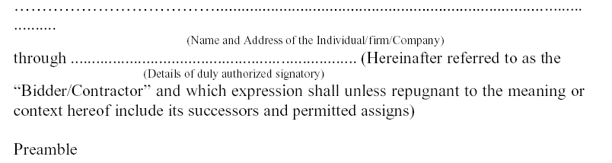

WHEREAS the Principal /Owner has floated the Tender (NIT No. 34/Civil/D2/2019-20/01) (hereafter referred to as “Tender / Bid”) and intends to award, under laid down organization procedure, contract for “Day to day maintenance of building in academic area Zone -II.”

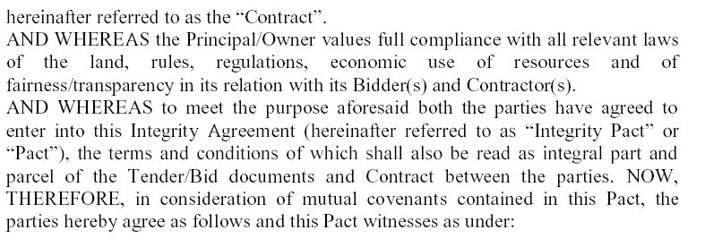
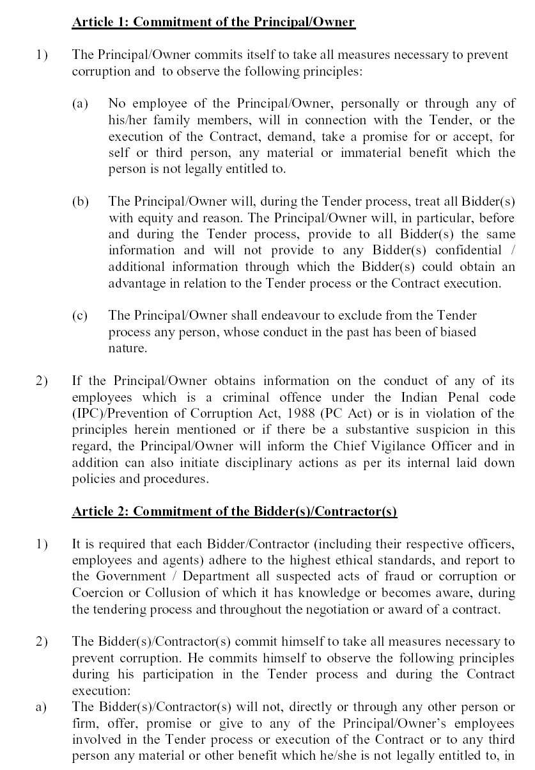
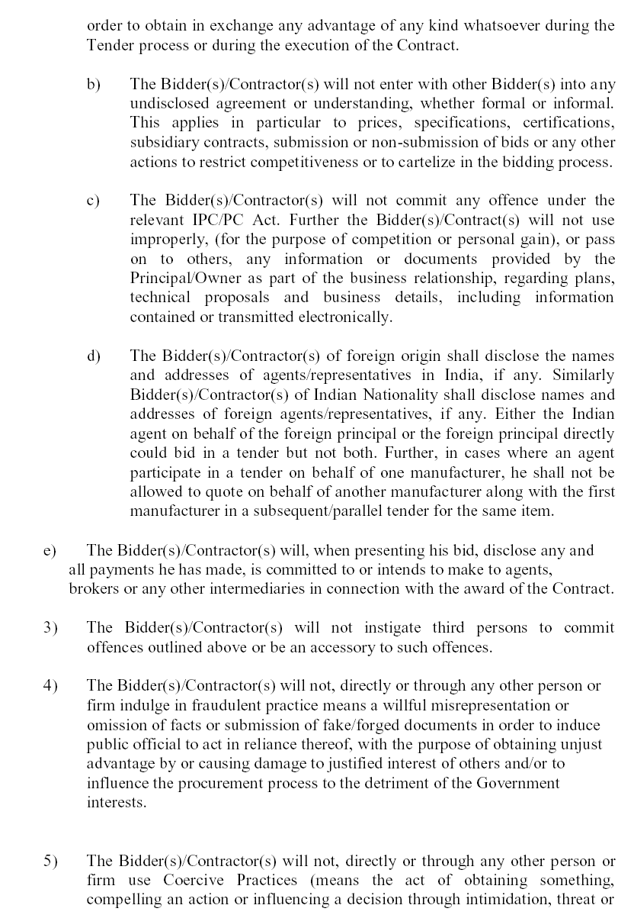

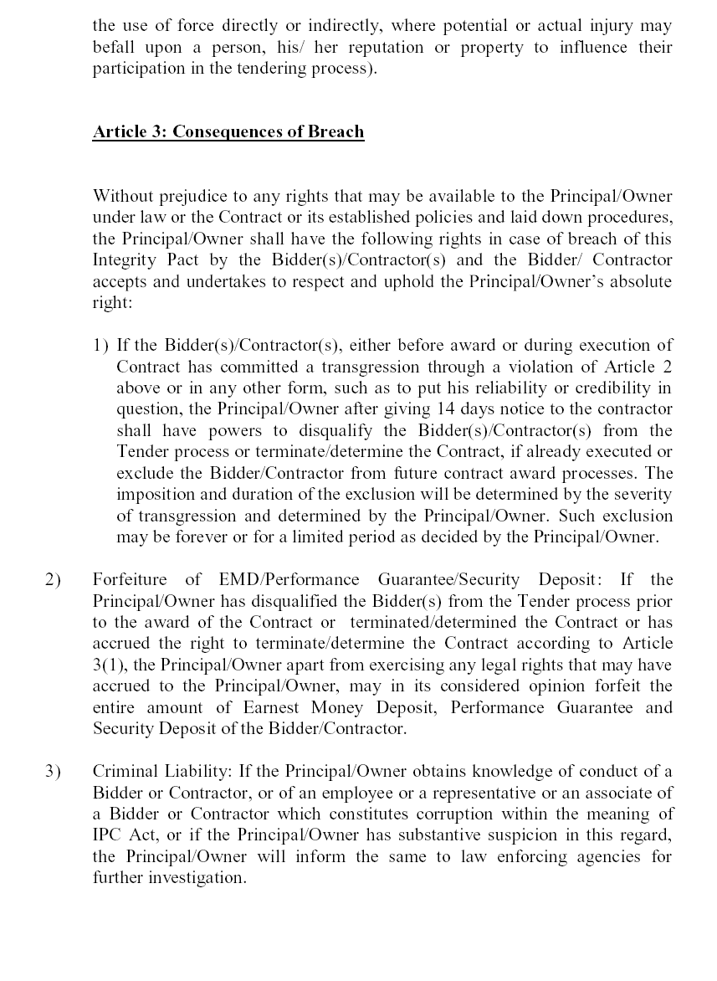

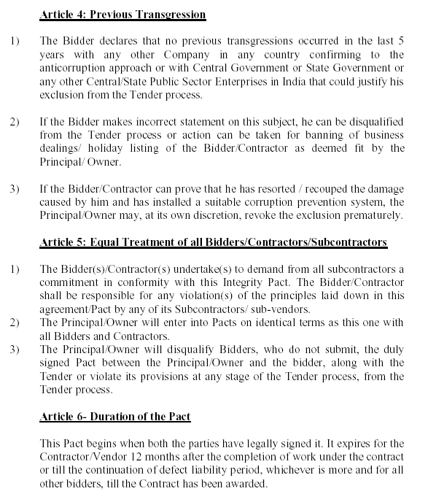

If any claim is made / lodged during the time, the same shall be binding and continue to be valid despite the lapse of this Pacts as specified above, unless it is discharged / determined by the Competent Authority, IIT Kanpur.

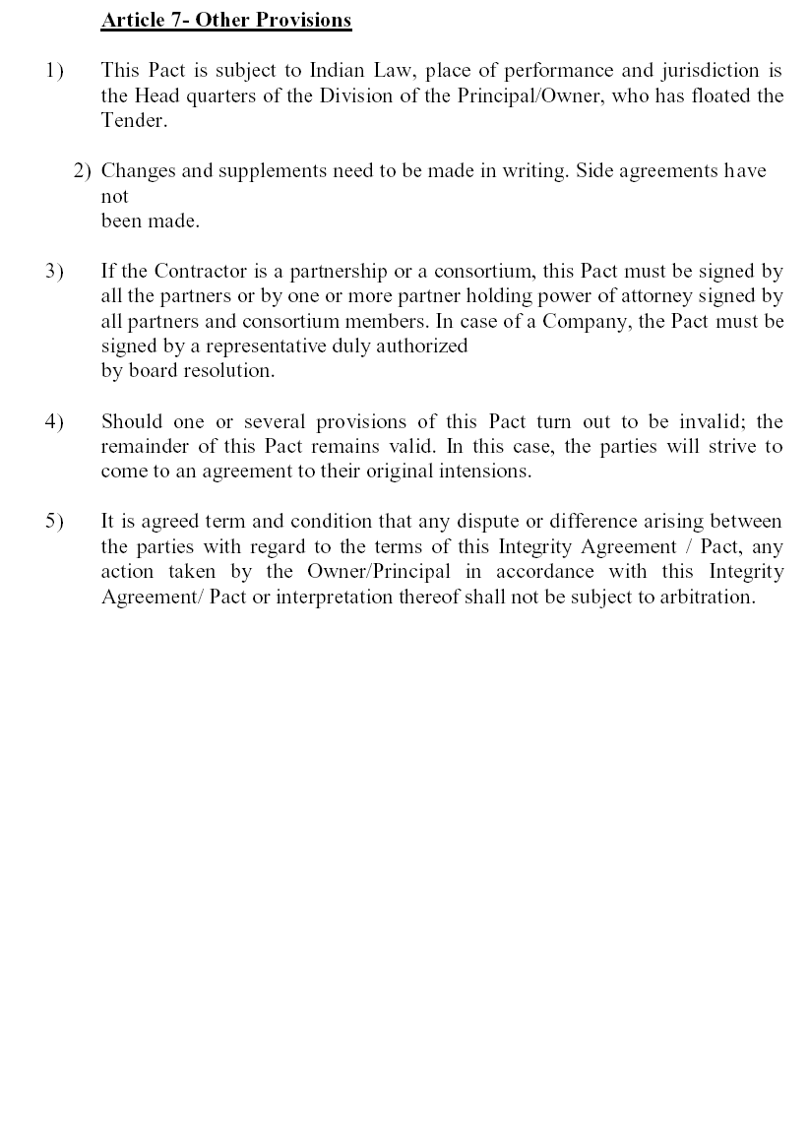

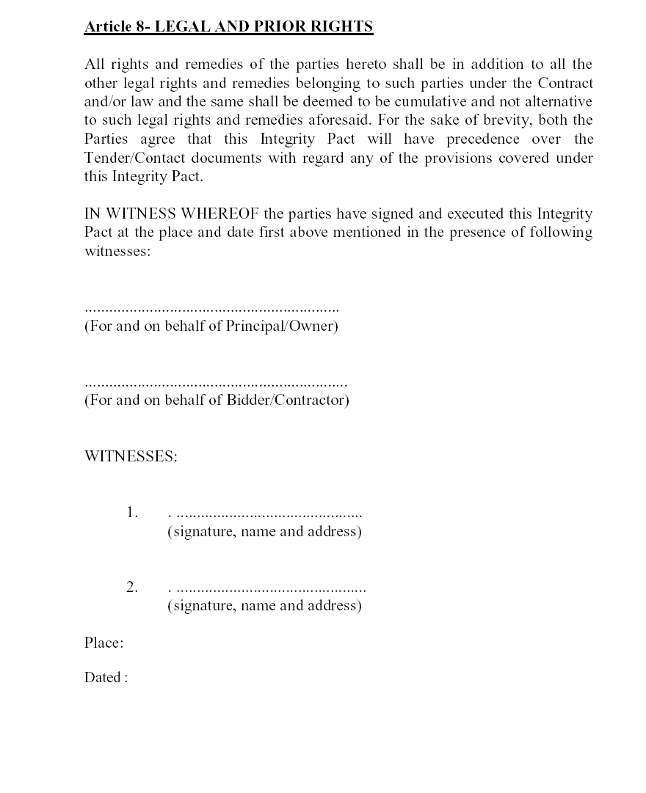

BANK GUARANTEE BOND
In consideration of the Board of Governors of IIT Kanpur (hereinafter called “the Government”) having agreed under the terms and conditions of agreement No. _______________________ dated ______________ made between _____________ and __________________ (hereinafter called “the contractor(s)”) ____________ for the work ____________________________________________________ (hereinafter called “the said agreement”) having agreed to production of a irrevocable Bank Guarantee for Rs. ___________ (Rupees _____________________________________ ______________________________________________ only) as a security/guarantee from the contractor(s) for compliance of his obligations in accordance with the terms and conditions in the said agreement, we
(hereinafter referred to as “the Bank”) hereby undertake to pay to the
(Indicate the name of the Bank)
Government an amount not exceeding Rs.__________ (Rs. ________________________________ only) on demand by the Government.

2. | We |  | do hereby undertake to pay the amounts due and payable
 |  | (Indicate the name of the Bank)
under this Guarantee without any demure, merely on a demand from the Government stating that the amount claimed is required to meet the recoveries due or likely to be due from the said contractor(s). Any such demand made on the bank shall be conclusive as regards the amount due and payable by the bank under this guarantee. However, our liability under this guarantee shall be restricted to an amount not exceeding Rs. _________ (Rupees __________________________________ only).

3. We, the said bank further undertake to pay to the government any money so demanded notwithstanding any dispute or disputes raised by the contractor(s) in any suit or proceeding pending before any court or tribunal relating thereto, our liability under this present being absolute and unequivocal.
The payment so made by us under this bond shall be a valid discharge of our liability for payment thereunder and the contractor(s) shall have no claim against us for making such payment.

4. | We |  | further agree that the guarantee herein contained shall
 |  | (Indicate the name of the Bank)
remain in full force and effect during the period that would be taken for performance of the said agreement and that it shall continue to be enforceable till all the dues of the Government under or by virtue of the said agreement have been fully paid and its claims satisfied or discharged or till Engineer-in-charge on behalf of the government certified that the terms and conditions of the said agreement have been fully and properly carried out by the said contractor(s) and accordingly discharges this guarantee.

5. | We |  | further agree with the Government that the Government
 |  | (Indicate the name of the Bank)
shall have the fullest liberty without our consent and without effecting in any manner our obligations hereunder to vary any of the terms and conditions of the said agreement or to extend time of performance by the said contractor(s) from time to time or to postpone for any time or from time to time any of the powers exercisable by the government against the said contractor(s) and to forebear or enforce any of the terms and conditions relating to the said agreement and we shall not be relieved from our liability by reason of any such variation, or extension being granted to the said contractor(s) or for any forbearance, act of omission on the part of the government or any indulgence by the Government to the said contractor(s) or by any such matter or thing whatsoever which under the law relating to sureties would, but for this provision, have effect of so relieving us.

- This guarantee will not be discharged due to the change in the constitution of the Bank or the contractor(s).

7. | We |  | lastly undertake not to revoke this guarantee except with
 |  | (Indicate the name of the Bank)
the previous consent of the Government in writing.

8. This guarantee shall be valid up to _____________, unless extended on demand by Government. Notwithstanding anything mentioned above, our liability against this guarantee is restricted to Rs. _________ (Rs. _______________________________only) and unless a claim in writing is lodged with us within six months of the date of expiry or the extended date of expiry of this guarantee all our liabilities under this guarantee shall stand discharged.

Dated the ___________________________ day of ______________________________________________
for
(Indicate the name of the Bank)

