Indian Institute of Technology Kanpur [**www.siicincubator.com/ipr**](http://www.siicincubator.com/ipr)

**Contact** **No.** **6178** **Intellectual Property Disclosure Form**

**1.** **Title** **of** **the** **invention:** **Antibacterial** **Nano** **breathing** **Nasal** **Filter**

**2.** **Innovator(s)** **who** **have** **contributed** **or** **conceived** **an** **essential** **element** **of** **the** **invention,** **either** **independently** **or** **jointly** **with** **others** **during** **evolution** **of** **the** **technology** **concept** **or** **reduction** **to** **practice:**

(i)Name: XYZ

Nationality: Indian

Position: Junior Technical Superintendent

Department Address: Imagineering Lab

Phone: 940xxx0912

Email: (IITK email ID is mandatory along with personal email ID for students) [abc@iitk.ac.in](mailto:abc@iitk.ac.in); [abc@gmail.com](mailto:abc@gmail.com)

Course: BTech, PhD…..etc

(ii)Name: XYZ

Nationality: Indian

Position: Junior Technical Superintendent

Department Address: Mechanical Engineering

Phone: 940xxx0912

Email: (IITK email ID is mandatory along with personal email ID for students) [abc@iitk.ac.in](mailto:abc@iitk.ac.in); [abc@gmail.com](mailto:abc@gmail.com)

Course: BTech, PhD…..etc

(iii)Name: XYZ

Nationality: Indian

Position: Professor

Department Address: Imagineering Lab

Phone: 940xxx0912

Email: (IITK email ID is mandatory along with personal email ID for students) [xyz@iitk.ac.in](mailto:xyz@iitk.ac.in); [xyz@gmail.com](mailto:xyz@gmail.com)

Course: (For Students) BTech, PhD…..etc

***\*****Inventors are requested to provide their Full Name (****without initials)****, Position (****e.g Professor / Associate Professor / Assistant Professor, Post Doc / Phd / M. Tech / B. Tech Student****), Phone Number (****Personal****), Email ID (****Official along with Personal****)*

***\*****Students are advised to provide their* ***home address*** *as well.*

*(****\*****Students* *are* *requested* *to* *give* *their* *home* *address* *and* *email* *other* *than* *squirrel* *mail* *as* *well)*

**3.** Non-Confidential description of the invention in layman’s Language:

|  |
| --- |
| 1. *Abstract in 100 words*   A nanotechnology based nasal air filter for breathing, the said filter comprising a base body (a) and at least two concha cartridges (b, b’). A nano-pad adapted to be fit inside a body vessel (a3) of the base body (a). Each of the concha cartridges (b, b’) is adapted to 10 receive a plurality of antibacterial layers (m1, m2, m3). The nasal filter as per the present invention comprises of micro-nano pillars, to remove all the undesirable matter from inhaled air. The herein disclosed nasal filter is capable of mimicking the natural breathing process, is compact in structure and is comfortable for the user to use. |
| 1. *Use Case*   The present subject matter describedhereinrelates to a nasalair filter, and more particularly, the invention relates to a nasal air filter based on nanotechnology for breathing by human beings that has antibacterial feature, which can mimic the natural breathing process and is comfortable to use. The Nasal filter will be useful for people living in polluted cities as well persons having allergy and suffering from Asthama & Bronchitis.  *Please consult examples provided in Annexure-1 for filling this section* |
| 1. *Keywords*   *Breathing* *filter+* *Nose* *filter+* *Micro* *Breathing* *Filter+* *Nano* *Breathing* *Filter+* *Micropillars+* *Nano* *Mats+* *Antibacterial+* *Flow* *rate+face* *mask+* *nose* *filters*  *Please be noted that the above keywords will be utilized by the IPR Cell for preparing Patent Search Report* |

**Note:** *The* *above* *Information* *will* *be* *circulated* *to* *several* *agencies* *for* *Commercialization* *purposes.*

**4.** **How** **does** **this** **invention** **relate** **to** **new** **processes,** **machines,** **compositions** **of** **matter,** **etc.?** **Please** **cover** **the** **following** **points:**

**(a)** Describe the invention in detail for technical evaluation. Please use additional sheets for sketches, drawing, photographs and other materials that help to illustrate the description. (Annexure-II Attached)

**(b)** What is Novel in the invention?

The current invention overcomes the requirement of bulky breathing filters embedded with face strap, the currentinvention has capability to filter at Nano-scale & also has the ability to kill microorganisms through theinternal cavity applied with anti-bacterial agent. The earlier nasal filters come without the feature of sanitization of internal cavity of the filter, but the current Nasal filter overcomes the drawbacks and has a feature of sanitization for the micro-organisms.

The Novel feature of the nasal filter is that it doesn’t minimizes the suction capacity of breathing process & the air flow suction remains the same to that of natural breathing process, mimicking the natural breathing process, hence this Nasal filter can be used during walking and running due toits lightweight and the clipping capacity ofthe silicone body parts at the top of the nasal filter.

**(c)** What is the “inventive” step in your invention? Is the step non-obvious to a person from related fields?

The current invention has several inventive steps & the steps involved in the development of this invention is non-obvious to a person skilled in related fields. The current invention has several parts with abbreviations & functionality given below

“a”-Base body made up of silicone material to provide adhesion capacity with the nose, so that the Nasal filter doesn’t drop while running and walking, the base body also has a clipping ability to hold the nose properly and doesn’t allow any air to pass through the distance between the nose and nasal filter.

“m”-Micro Pad contains adhesion strips having micro-Nano-pillars, these micro-Nanopillars trap the PM 2.5 particle mimicking the natural nasal property. The PM 2.5 particles get entrapped in the micro-Nano-Pillars, thereby allowing only clean air.

“n1”, “n2”- Nano Mats are placed at n1 & n2 for the adhesion of pathogenic bacteria’s & other Nano particles, allowing only air to pass through it. The micro-nano pad also

*PCT/ International filing is subject to support from the Project funds of the Inventor.

entraps the moisture present in the air allowing only dry air to pass through, which will be beneficial for the patients of Asthma & Bronchitis.

“m1”, “m2”, “m3”- Antibacterial gel layered over the surface to sanitize the area free fromany bacterial germination in the nasal filter cavity.

“Ce”- Concha Exhale opens only at the time of inhaling air and gets closed during breathing the air out, the “a” portion opens up allowing the air go out while exhaling, during the process of exhaling the “Ce” gets closed.

**(d)** What are the advantages of the present invention over comparable inventions available in patent literature? Please attach a summary of your patent search*.

The current invention has several advantages over existing nasal filters

i.e. US2282681A, US6701924B1, US20040261798A1, US6561188B1, US20070227542A1

1. The current invention doesn’t needs insertion inside the nostrils.

2. The invention doesn’t needs any face straps for support, since it has silicone body with clipping ability for attachment to the nose.

3. The current invention works at 2 scales i.e. Micro & Nanometer

4. The current invention has cell adhesion properties for bacterial cells, PM2.5 particle entrapment through micro-nano pillars.

5. This invention also sanitizes the internal cavity of the nasal filter through antibacterial gel, mimicking the natural process of internal nasal cavity where the mucus is produced after detecting pathogen.

6. The person wearing the nasal filter can use it for inhaling and exhaling & if needed can also talk & eat while wearing the mask

**(e)** NOTE: The inventors should go through the Patent Search report carefully and write the difference between his invention and each contents of the patent search. For Patent search please contact ipr@iitk.ac.in

**(f)** Has the invention been tested experimentally? Are experimental data available?

No

**(g)** Technology Readiness Levels (**TRL**) description (mention the applicable stage of TRL given below). Please Mark as Appropriate

**TRL-1**

**Research** **Idea**

(Potential Application/Basic Principles observed)

**TRL-2**

**Applied** **Research** **Idea**

(Hypothesis testing and initial proof of concept is demonstrated in a limited number of trials)

**TRL-3**

**Project** **Plan**

(Device Characteristics documents & project proposal completed, Proof-of concept phase)

*Submission of IPDF soft copy is Mandatory at the time of Patent document submission.

**TRL-4**

**Design** **and** **Development**

(POC & Safety of device demonstrated by prototype design)

**TRL-5** **Standardization**

(Validating the result of the prototype by testing in simulated environment)

**TRL-6**

**Preclinical** **Evaluation**

(Clinical trials of functional prototype)

**TRL-7**

**Technology** **Transfer**

(Technology transfer of the developed system)

**TRL-8**

**Clinical** **Evaluation**

(Evaluation of the system by clinical trials or demonstration)

**TRL-9** **Commercialization**

(Commercialization & Post Market Surveillance)

**(h)** **Need** **and** **Demand**

*(Technology* *gaps* *addressed* *in* *domestic* *&* *international* *markets,* *pain* *points* *of* *Industry* *which* *are* *being* *resolved)*

*The* *degradation* *of* *the* *quality* *of* *air* *at* *an* *alarming* *rate* *has* *given* *rise* *to* *the* *need* *of* *filters,* *and* *protective* *masks* *for* *removal* *of* *unwanted* *matter* *from* *the* *air* *that* *a* *person* *breathes* *in.* *Besides,* *there* *are* *individuals* *who* *are* *allergic* *to* *certain* *particles* *and* *there* *are* *individuals* *who* *work* *in* *occupations* *that* *demand* *exposure* *to* *particulate* *matter* *such* *that* *they* *inhale* *these* *undesirable* *matters* *into* *the* *respiratory* *system* *of* *their* *body.* *The* *quality* *of* *air* *in* *cities* *has* *decreased* *due* *to* *pollution* *that* *it* *is* *advisable* *to* *use* *a* *mask* *to* *filter* *the* *air* *a* *person* *breathes* *in.*

*PCT/ International filing is subject to support from the Project funds of the Inventor.

**(i)** **Market** **Access** **Information**

(Current Global & domestic Scenario, market size & CAGR)

India pollution mask market is projected to grow at a CAGR of more than 18% by 2023, on the back of growing health concerns due to deteriorating air quality in the country, especially across the urban areas. Increasing CO2 emissions due to surging industrial activity and expanding vehicle fleet, rising sales of pollution masks through online channels and intensifying competition are some of the other factors expected to boost pollution masks market in the country over the course of next five years. Moreover, increasing per capita expenditure on healthcare and safety products and rising consumer awareness regarding respiratory diseases and benefitsofantipollution products are anticipated to fuel demand for pollution masks in India in the coming years.

**(j)** **Future** **Developments**

(Scope of future technology development and their application)

This Nasal filter may be modified to add embedded sensors, giving real time data of the air quality being inhaled. The real time data can be obtained in a smartphone through Bluetooth data transmission.

**(k)** **Application/s** **of** **the** **invention** (Please refer to appendix-I)

The present subject matter described herein relates to a nasal air filter, and more particularly, the invention relates to a nasal air filter based on nanotechnology for breathing by human beings that has antibacterial feature, which can mimic the natural breathing process and is comfortable to use. The Nasal filter will be useful for people living in polluted cities as well persons having allergy and suffering from Asthama & Bronchitis.

**5.** **IPR** **Ownership**

**(a)** Was the intellectual property created with the significant use of funds or facilities of IITK?

Yes

**(b)** Please describe any source of funding for the invention (Name of the funding agency and copy of agreement, letter of intent if any, must be enclosed with this form)

IITK

**(c)** What is the source of Salary/Remuneration of inventor/Co-inventor?

IITK

**(d)** Have you presented in any conference, seminar, etc., if yes, please give details?

No

**(e)** Have you published full/part of this invention, if yes, please give copy of publications?

No

**(f)** Was the intellectual property created in the course of or pursuant to a sponsored/consultancy research agreement with IITK? If yes, please enclose a copy of MOU with concerned project.

*Submission of IPDF soft copy is Mandatory at the time of Patent document submission.

No

**(g)** Was the intellectual property created as a part of academic research leading towards a degree or otherwise?

No

**(h)** **REVENUE** **SHARING** **AMONG** **INVENTORS:** Please disclose the extent of contribution of each inventor in the invention in percentage terms for revenue sharing.

**NAME** **OF** **THE** **INVENTOR** **%** **SHARE\*** **SIGNATURE**

**1.** Santosh Pramanik 70%

**2.** XYZ 30%

**\*** If this column is not filled and signed then it will be assumed that all inventor(s) have equal contribution

**6.** **Commercial** **potential**

Give brief description of potential commercialization by specifying

**(i)** Why should the individual(s)/organization may consider procuring this innovation?

The current invention is the only solution of its kind, in the category of breathing filter, that solves the problem of reduction in breathing flow rate along with efficient

filtration. None of the existing products offer a combination of natural breathing flow rate along with efficient filtration capacity.

**(ii)**These question are related to the question (i) above:

**a.** In your opinion what are the steps/processes must be undertaken by the procurer to commercialize the use of this innovation?

The procurer needs to modify the aesthetics, the procurer will also need regulatory license for the manufacturing of the nasal filter i.e. Manufacturing License to State Drugs Control Organisation (or maybe register in CDSCO Head Quarters and say that it is equivalent to CLENARE and NASOFILTERS (made in India) and obtain Marketing Authorisation.

**b.** How long may it take to reach the commercial stage by the procurer? 6 months

**(iii)**Please give specific list of companies and contact details of concerned person who can be contacted for initiating Technology Licensing

|  |  |  |  |
| --- | --- | --- | --- |
| S. No. | Name of Companies | Name of the contact person | Contact no. |

*PCT/ International filing is subject to support from the Project funds of the Inventor.

|  |  |  |  |
| --- | --- | --- | --- |
| 1. | 3M |  | 1-800-425-3030 |
| 2. | Nasal Medical |  |  |
| 3. | Nasofilters |  | (+91)-(11)-45656700 |
| 4. | SANISPIRA |  |  |

(\**Unsigned* *&* *Incomplete* *IPDF* *forms* *will* *not* *be* *accepted*).

**(iv)** Do you want to file Patent under PCT Route in other countries?

Yes No

*PCT & Foreign filing is subject to monetary support from the inventor(s) Project / Personal Account. If the above option is marked “yes”, kindly provide the Project Account Details from which the filing cost could be reimbursed.

Project Account Name: MISC/2015/202213

Project Account No.: 20258568

**\*The institute shall file patent under PCT route only in those cases wherein industry/company has exhibited interest for commercialization.**

**Disclaimer:** *I/We declare that before the submission of this disclosure form or/and during*

*the process of filing this invention as an IPR prospect, I/We will not publish the above information in public domain.*

*I/We also give consent to IIT Kanpur being the applicant of this IPR prospect, that they may use this disclosure upon their discretion, which will not be limited to publication on e-auction website, Industry meets & different portals for promotional & licensing purposes.*

____________________________

Signature of Inventor with date

________________________

Signature of Inventor with date

*Submission of IPDF soft copy is Mandatory at the time of Patent document submission.

**Annexure- I**

***Illustrated examples for mentioning use case of Product/ Process***

***1.*** ***“Classification*** ***of*** ***Hard*** ***and*** ***Soft*** ***Taps*** ***on*** ***Capacitive*** ***Touch*** ***Screen”*** ***having*** ***application*** ***in*** ***below*** ***mentioned*** ***use*** ***case:***

*We* *all* *use* *capacitive* *touch* *screens,* *on* *a* *series* *of* *devices* *starting* *with* *smart* *watches,* *smartphones* *tablets* *laptops* *and* *desktops.* *The* *only* *thing* *you* *can* *do* *on* *the* *present* *touch* *screens* *is* *to* *indicate* *a* *location,* *by* *touching* *it* *there.* *It* *doesn't* *matter* *whether* *you* *touch* *it* *hard* *or* *lightly* *-* *the* *touch* *is* *definitely* *not* *3D.* *iPhone* *X* *has* *attempted* *to* *introduce* *this* *feature* *(forcetouch)* *by* *including* *expensive* *special* *pressure-sensitive* *hardware.* *We* *adopt* *a* *different* *approach,* *that* *requires* *you* *to* *only* *install* *an* *app* *on* *the* *existing* *device.* *With* *this* *the* *same* *touch* *screen* *that* *you* *have* *been* *using* *now* *becomes* *sensitive* *to* *at* *least* *two* *levels* *of* *pressure,* *light* *and* *heavy.* *Every* *other* *app* *developer* *can* *now* *exploit* *this* *feature* *and* *provide* *more* *sophisticated* *user* *interfaces* *which* *can* *distinguish* *levels* *of* *touch.* *The* *possibilities* *are* *limited* *only* *by* *the* *imagination.* *As* *the* *technology* *matures,* *a* *larger* *number* *of* *levels* *of* *touch* *is* *likely* *to* *be* *supported.*

***2.*** ***“Antibacterial*** ***Nano*** ***breathing*** ***Nasal*** ***Filter”*** ***having*** ***application*** ***in***

*Many* *people* *use* *face* *mask* *for* *breathing* *pollution* *free* *air,* *but* *the* *main* *constraint* *in* *breathing* *is* *decrease* *in* *breathing* *flow* *rate.* *The* *innovation* *described* *herein* *relates* *to* *a* *nasal* *air* *filter,* *and* *more* *particularly,* *the* *invention* *relates* *to* *a* *nasal* *air* *filter* *based* *on* *nanotechnology* *for* *breathing* *by* *human* *beings* *that* *has* *antibacterial* *feature,* *which* *can* *mimic* *the* *natural* *breathing* *process* *i.e.* *12-15* *lpm* *and* *is* *comfortable* *to* *use.* *The* *nasal* *filter* *will* *be* *useful* *for* *people* *living* *in* *polluted* *cities* *as* *well* *persons* *having* *allergy* *and* *suffering* *from* *Asthama* *&* *Bronchitis.*

***3.*** ***“A*** ***method*** ***of*** ***measuring*** ***BMP*** ***signaling*** ***using*** ***BMP*** ***responsive*** ***reported*** ***cell*** ***line”*** ***having*** ***application*** ***in***

Bone Morphogenetic Protein (BMP) signaling is necessary and sufficient for bone formation. It is present in several biological samples measurement of which may have diagnostic value. However, at present there is no sensitive method of detecting BMP proteins in a biological sample. In this disclosure we describe creation of a cell line based sensitive and accurate method of estimating BMP proteins in any specimen.

***4.*** ***A*** ***unique*** ***device*** ***for*** ***plasma*** ***processing*** ***to*** ***simulating*** ***magnetospheres*** ***in*** ***the*** ***laboratory*** *The* *dipole* *plasma* *device* *would* *be* *helpful* *in* *industry* *for* *plasma* *processing* *of* *samples* *such* *as* *in* *the* *semiconductor* *industry,* *where* *energetic* *electrons* *(or* *ions)* *are* *required* *to* *impinge* *on* *a* *substrate* *and* *to* *bring* *about* *desired* *changes* *in* *the* *substrate* *such* *as* *plasma* *assisted* *ion* *doping,* *etching,* *or* *creation* *of* *nanostructures* *on* *metallic* *surfaces,* *the* *device* *would* *be* *helpful* *in* *understanding* *the* *physics* *of* *plasmas* *confined* *in* *a* *magnetic* *dipole.*

***5.*** ***Large*** ***area*** ***micro-texturing*** ***on*** ***free-form*** ***surfaces*** ***using*** ***flexible-electrode*** ***throughmask*** ***electrochemical*** ***machining***

Surface micro-texturing deals the issues pertaining to various fields of engineering for enhancing the essential functions such as tribological, wetting, biocompatibility, sustainability, cleanliness etc. Among all the aforementioned sectors, micro-texturing of free-form large

*PCT/ International filing is subject to support from the Project funds of the Inventor.

areas is getting huge attention, e.g. micro-textures on artificial biomedical implants enhances sustainability and life cycle by better implant-tissue interface, cell-adhesion and cell proliferation. Micro-textures on cylindrical surfaces (both internal and external) of bearings, piston rings, hypodermic needles assists in reducing the coefficient of friction and facilitating lubrication.

*\*This* *page* *is* *for* *reference* *purpose,* *no* *need* *to* *print* *this* *page.* **Anexure-I**



*Submission of IPDF soft copy is Mandatory at the time of Patent document submission.

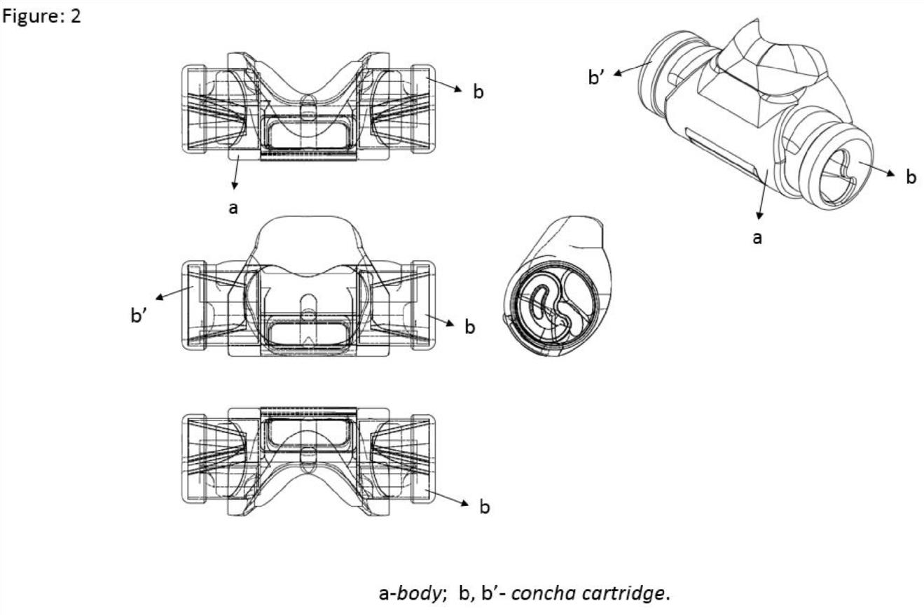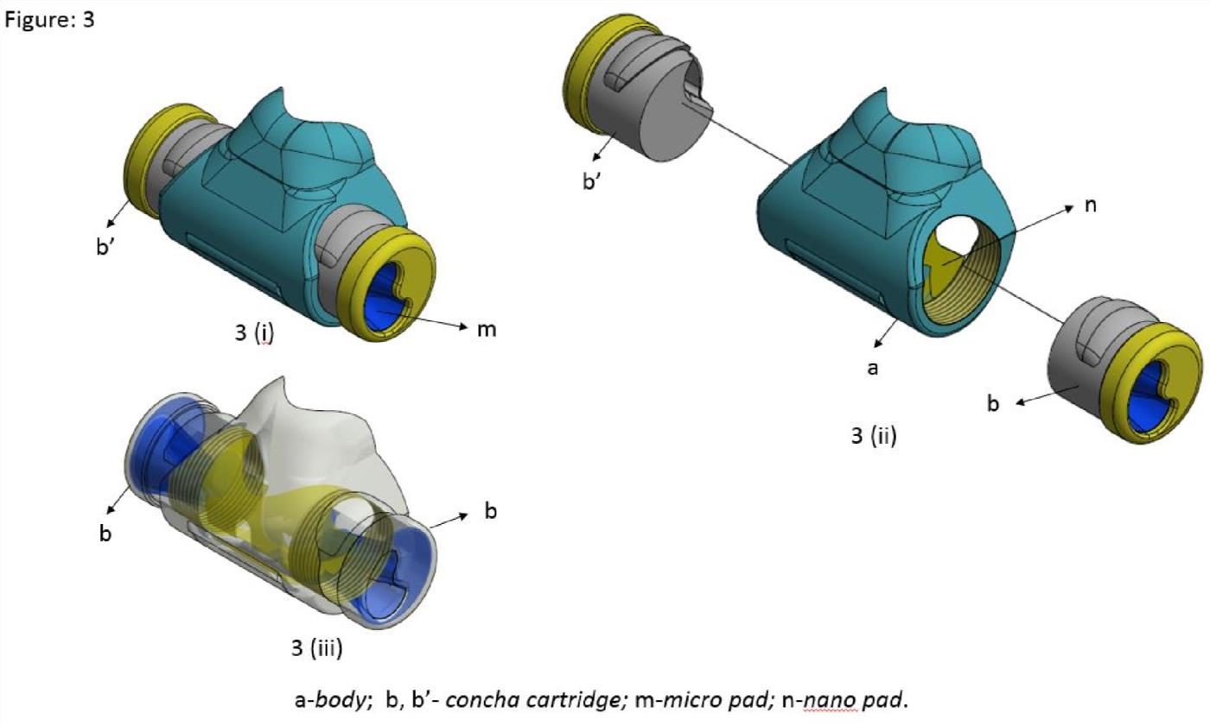

*PCT/ International filing is subject to support from the Project funds of the Inventor.

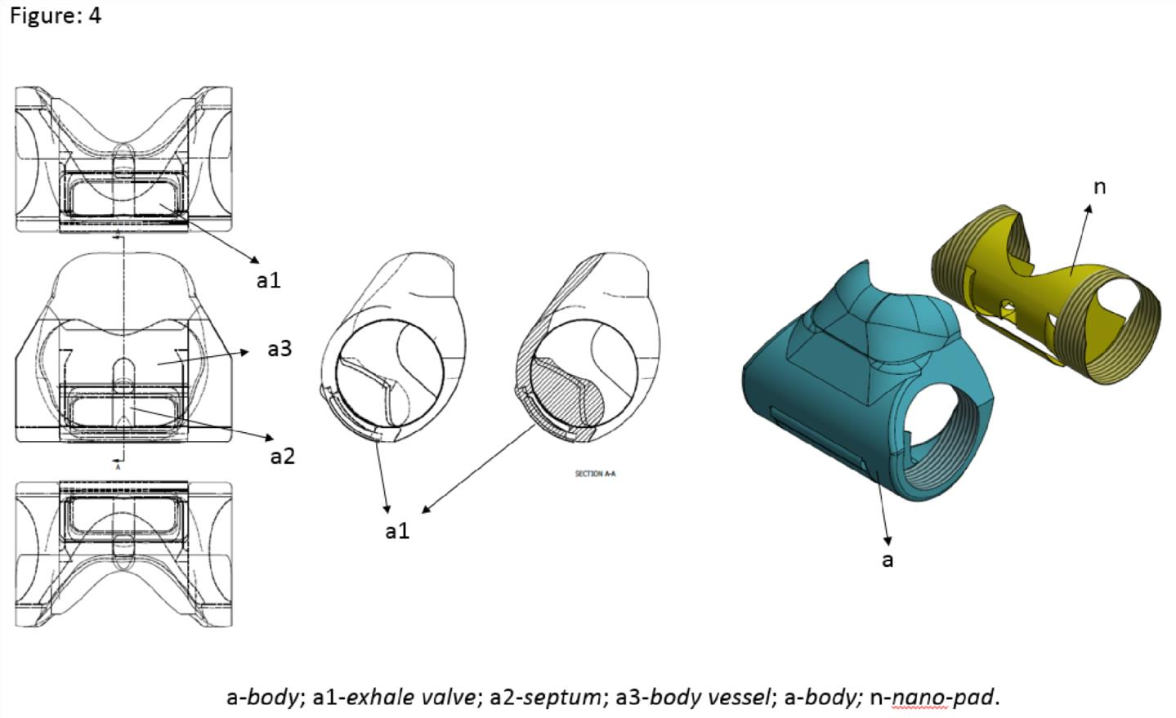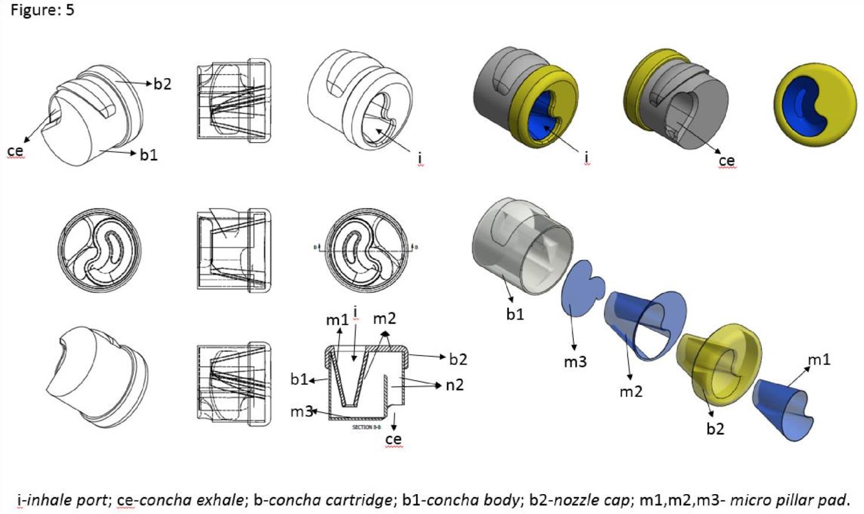

*Submission of IPDF soft copy is Mandatory at the time of Patent document submission.

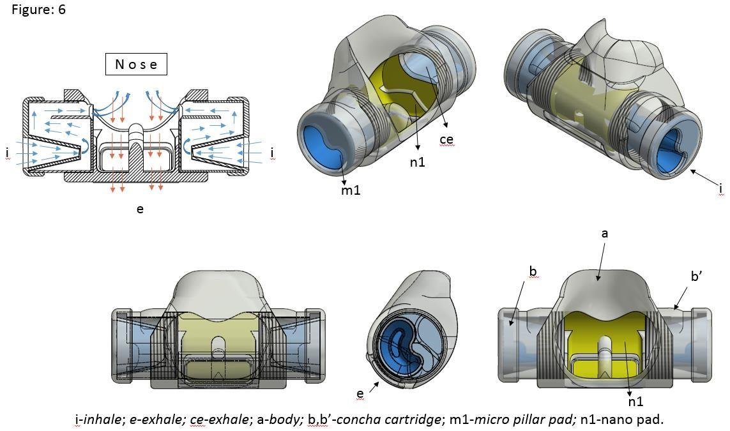

*PCT/ International filing is subject to support from the Project funds of the Inventor.