RIGAKU
MiniFlex 600 XRD
POWDER OPERATING MANUAL
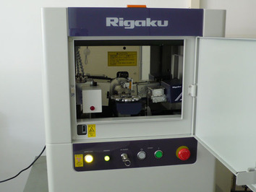

Advanced Centre for Materials Science
IIT Kanpur

Facility Convener
Dr. Nilesh Prakash Gurao
Assistant Professor
MSE Department, IIT Kanpur
OPERATING PROCEDURE FOR POWDER MODE
I. PROCEDURE FOR STARTING MACHINE & RUNNING TEST
- Switch on the main power MCB.
- Switch on the UPS and wait until green light appears.
- Switch on the Chiller MCB.
- Turn on 3 switches for plugged-in points behind Rigaku instrument (to start computer, instrument etc.)
- Power on XRD machine by pressing GREEN coloured button on Rigaku instrument.
- Check if the High Voltage Enable Key is in horizontal position. If it is vertical, turn the key clockwise to make it horizontal.
- Insert sample and press the door lock button to lock the door.

- Double-click the MiniFlex icon on the desktop to start the software. You will see following dialog box. Wait for few seconds until this message and other pop-up messages disappear.
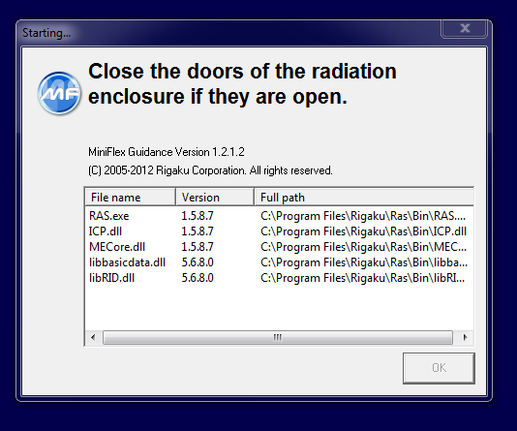
- If machine was used previously on the same day, proceed to step 11. But if you are starting the machine for the first time in the day, go to Startup.
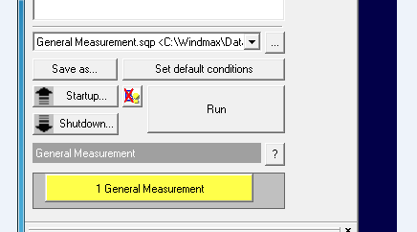
- Select Generator Usage from drop-down depending on previous use of the machine (e.g. if machine was used previous day, select “Use everyday”). Click on Execute.
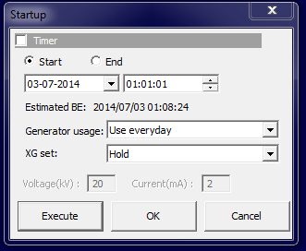
- Select Control XG Control.
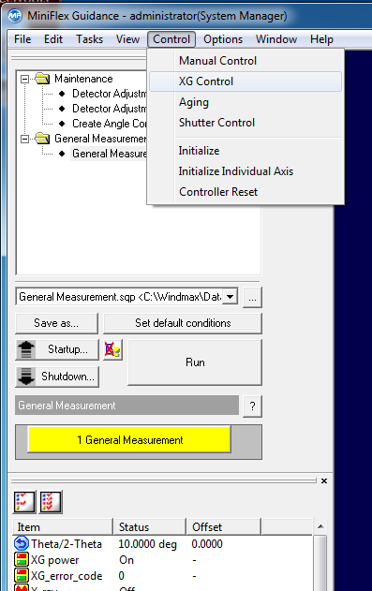
- Switch ON X-Ray. A pop-up will appear on top left of screen. Wait until X-Ray is switched on and the pop-up disappears. Then Close XG Control dialog box.
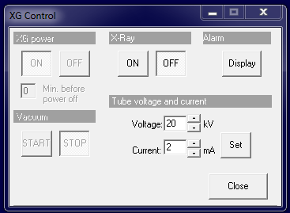

- Select 1 General Measurement. In General Measurement window, Browse for folder where you want to save your data and specify the File name and Sample name. Then select Set Meas. Conditions.
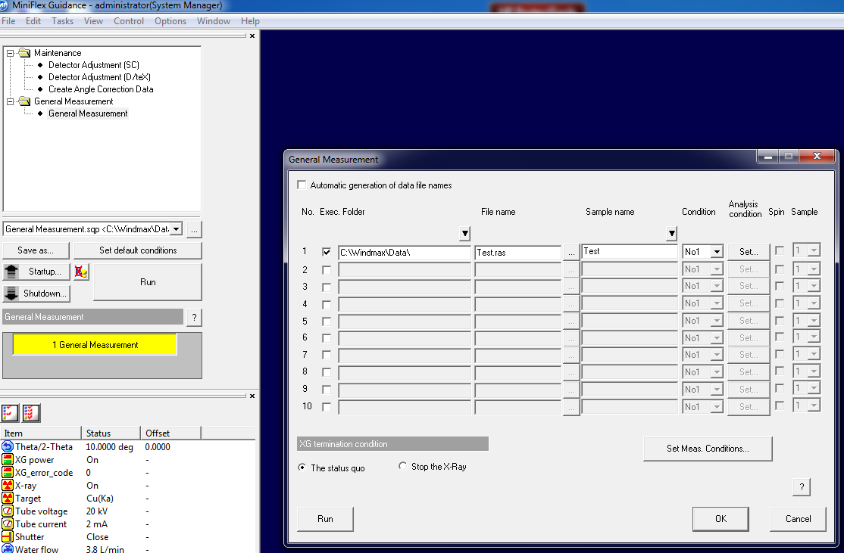
Browse
- In the Set Meas. Conditions window, specify Start Angle, Stop Angle, Step and Speed. (If necessary, change Voltage & Current which are usually 30V and 10 mA respectively)
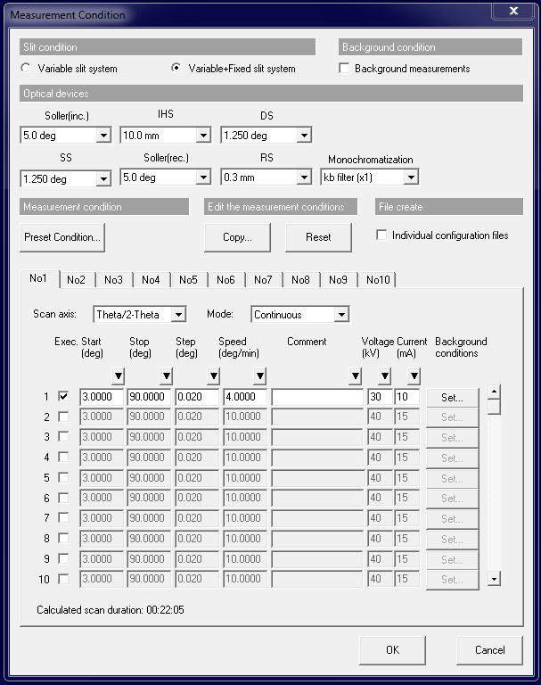
Click OK. Window will close.

- In MiniFlex main window, Click Run to start the test.
- Before starting next test, click Close from the File menu to avoid overlap of new test result with previous one.

II. PROCEDURE FOR MACHINE SHUT DOWN AFTER TEST
- Go to Control XG Control. Change the Voltage to 20 V and Current to 2 mA. Then Switch OFF X-Ray.
- File Exit the MiniFlex main window.
- Switch off XRD machine by pressing white coloured button on Rigaku instrument.
- Turn off 3 switches for plugged-in points behind Rigaku instrument (to power off computer, instrument etc.)
- Wait for 5 minutes.
- Switch off Chiller MCB.
- Switch off UPS.
- Switch off main MCB.

