AUGUST 21-23, 2024

Indian Institute of Technology Kanpur, India

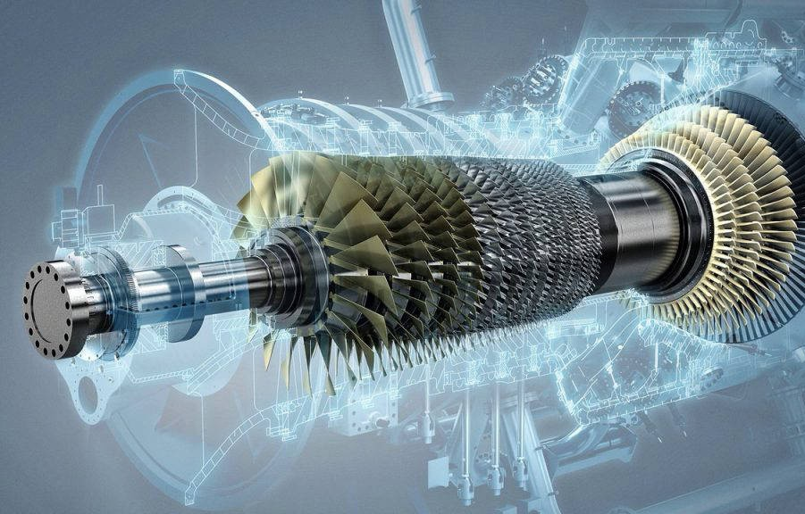

**Asian Congress on**

**Gas Turbine 2024**

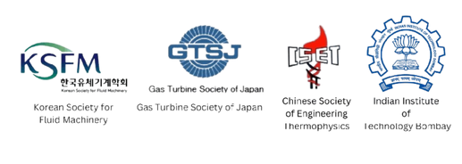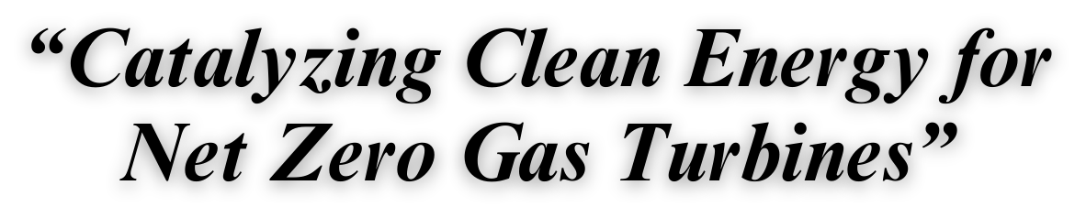

|  |  |  |  |
| --- | --- | --- | --- |
|  | **Time** | **Event** | **Venue** |
| **Day 1, August 21, 2024, Wednesday** | 8:00 to 9:00 | Registration | OL |
| 9:00 to 10:30 | **Inauguration and Keynote session** | OA |
| 10:30 to 11:00 | **High Tea** | OL |
| 11:00 to 12:00 | Session 1 | OA |
| 12:00 to 13:00 | Session 2 | OA |
| 13:00 to 14:00 | **Lunch** | OL |
| 14:00 to 15:00 | Session 3 | OA |
| 15:00 to 16:00 | Session 4 | OA |
| 16:00 to 16:20 | **Tea break** | OL |
| 16:20 to 17:20 | Session 5 | OA |
| 17:45 to 18:30 | Lab visit |  |
| 18:30 to 19:30 | Free time |  |
| 19:30 to 21:30 | **Dinner** | OL |
| **Day 2, August 22, 2024, Thursday** | 9:00 to 10:00 | **Keynote session** | OA |
| 10:00 to 11:00 | Session 6 | OA |
| 11:00 to 11:20 | **Tea break** | OL |
| 11:20 to 12:20 | Session 7 | OA |
| 12:20 to 13:20 | Session 8 | OA |
| 13:20 to 14:10 | **Lunch** | OL |
| 14:10 to 15:10 | Session 9 | OA |
| 15:10 to 16:10 | Session 10 | OA |
| 16:10 to 16:30 | **Tea break** | OL |
| 16:30 to 17:30 | Session 11 | OA |
| 17:30 to 18:30 | Lab visit |  |
| 18:30 to 19:30 | Free time |  |
| 19:30 to 21:30 | **Dinner** | OL |
| **Day 3, August 23, 2024, Friday** | 9:00 to 10:00 | Pannel Discussion | OA |
| 10:00 to 11:00 | Session 12 & 13 | OA/OSR |
| 11:00 to 11:20 | **Tea Break** | OL |
| 11:20 to 12:20 | Session 14 & 15 | OA/OSR |
| 12:20 to 13:20 | Session 16 & 17 | OA/OSR |
| 13:20 to 14:20 | **Lunch** | OL |
| 14:20 to 15:20 | Session 18 & 19 | OA/OSR |
| 15:20 to 16:20 | Session 20 & 21 | OA/OSR |
| 16:20 to 16:45 | Event Conclusion | OA |
| 16:45 to 17:00 | **Tea Break** | OL |
| 17:00 to 19:30 | Free Time |  |
| 19:30 to 21:30 | **Dinner** | OL |

**Total time for a presentation: 20 mins**

**15 mins talk + 5 mins discussion**

|  |  |  |  |
| --- | --- | --- | --- |
| **Day 1**  **Wednesday, 21st August 2024** | | | |
| **Time** | **Event** | | **Venue** |
| 8:00-15:00 | Registration | | OL |
| 9:00 | Inauguration &  Keynote Session-1 (Dr. R.K. MISHRA - CEMILAC, Bangalore, India) | | OA |
| 10:40 | Tea Break | | OL |
| **Session 1**  **Combustion-1** | | | |
| 11:00 | Combustion Dynamics Study of Biofuels in A Swirl Stabilized Combustor  *Satender Singh (IIT, Madras)* | | OA |
| 11:20 | Effect Of Hydrogen Enrichment on Soot Formation in Laminar Ethylene Diffusion Flames  *Kundan Kumar (IISc, Bengaluru)* | | OA |
| 11:40 | Response Of Partially Premixed Swirl Flame to Transverse Acoustic Excitation  *Ravi Gupta (IISc, Bengaluru)* | | OA |
| **Session 2**  **Structures-1** | | | |
| 12:00 | Ti-900: An Alloy for Gas Turbine Compressor Blades Application  *Dipayan Chakraborty (IIT, Tirupati)* | | OA |
| 12:20 | Investigation The Mechanical Properties of Hot-Rolled Aluminium Alloy Plate 7075-T651: Insights for Aerospace Application  *Nguyen Tien Quyet (Viettel group)* | | OA |
| 12:40 | Topology Optimization and Additive Manufacturing Simulation in Ansys  *Satyen Badakh (IIT, BHU)* | | OA |
| 13:00 | **Lunch** | | OL |
| **Session 3**  **Combustion-2** | | | |
| 14:00 | Numerical Investigation on The Aerodynamic Characteristics of a Lean-Burn Gas Turbine Fuel Injector    *Preetam Jamod (IIT, Jammu)* | OA | |
| 14:20 | Injector Exit Geometry Variations on The Spray Characteristics of An Effervescent Injector  *Harsh Saria (IIST, Thiruvananthapuram)* | OA | |
| 14:40 | The Numerical Simulation of Dynamics of a Droplet Upon Impacting an Inclined Surface  *Arnab Chakraborty (TCS research)* | OA | |
| **Session 4**  **Heat transfer -1** | | | |
| 15:00 | A Study on The Development of An Afterburner for A Supersonic Micro Gas Turbine for Small High-Speed UAVs  *DongEun Lee (University of Science and Technology, South Korea)* | OA | |
| 15:20 | Depressurized Boiling Flow Analysis in Nozzle for Cryogenic Gas-Liquid Two-Phase Flow Measurement  *Sakai Shin (University of Tokyo, Japan)* | OA | |
| 15:40 | Estimation Of Non-Gray Radiative Heat Flux with Soot in Lox-Methane Rocket Thrust Chamber  *Pradeep Kumar (IIT, Mandi)* | OA | |
| 16:00 | **Tea Break** | OL | |
| **Session 5**  **Turbomachinery-1** | | | |
| 16:20 | Design And Analysis of Purge Flow Path on The Performance of The High Pressure Transonic Axial Turbine  *Pitchai Pillai Sharmila (IIT, Madras)* | OA | |
| 16:40 | Analysis Of The 3D Flow Structure Within Gas Turbine Blade Lattice Cooling Channels Using Magnetic Resonance Velocimetry  *Jumin Hong (Seoul National University, South Korea)* | OA | |
| 17:00 | Coupled Transition and Turbulence Models for Low Pressure Turbine Flows Using Multi-Objective Data-Driven Frameworks  *Harshal Deepak Akolekar (IIT, Jodhpur)* | OA | |
| **Day 1 Technical sessions concluded** | | | |
| 17:45 | **Lab Visit** | | |
| 19:30 | **Dinner**  **Venue:** OL | | |

|  |  |  |  |  |  |
| --- | --- | --- | --- | --- | --- |
| **Day 2 - Thursday, 22nd August 2024** | | | | | |
| 8:00-15:00 | Registration | | | OL | |
| 9:00 | Keynote Session 2 – sivarama krishna SC “G”, GTRE, Bangalore, India | | | OA | |
| **Session 6**  **Intake/Exhaust** | | | | | |
| 10:00 | Effects Of Inlet Distortion on Boundary Layer Ingesting Propulsion System Performance  *Seisuke Hirayama (University of Tokyo, Japan)* | | | OA | |
| 10:20 | Experimental Investigation of IR signature On Circular and Serpentine Nozzles  *Dinesh Durai (IIT, Kanpur)*  *Tarun Kurakula (IIT, Kanpur)* | | | OA | |
| 10:40 | Experimental Investigation of Secondary Fluidic Velocity Influence on Primary Jet Mixing for Active Flow Control  *Lohitvel Gopikannan (Anna University, Chennai)* | | | OA | |
| 11:00 | **Tea break** | | | OL | |
| **Session 7**  **Turbomachinery -2** | | | | | |
| 11:20 | Numerical Simulations of a Transonic Axial Compressor with Roughness Near the Onset of Stall  *Pradeep A.M. (IIT, Bombay)*  *Harshal Deepak Akolekar (IIT, Jodhpur)* | | | OA | |
| 11:40 | Effects Of Additive Manufacturing-Induced Thickened Leading Edge on Aerodynamic Performance of Compressor Blade  *Youngeon Ko (Seoul National University)*  *Seung Jin Song (Seoul National University)* | | | OA | |
| 12:00 | Numerical Investigations on Delay in Onset Of Inflection For S-Shaped Compressor Airfoil Flow Characteristics  *Chetan Mistry (IIT, Kharagpur)* | | | OA | |
| **Session 8**  **Combustion-3** | | | | | |
| 12:20 | Effect Of Hydrogen Addition Over the Flame Characteristics of Methane-Air Partially Premixed Swirl Flame  *Ravi Gupta (IISc, Bengaluru)* | | | OA | |
| 12:40 | Engine Fire Extinguishing Agent Concentration Studies and Validation for Pusher-Propeller Aircraft  *Vinay C A (CSIR-National Aerospace Laboratories, Bangalore)* | | | OA | |
| 13:00 | Numerical Investigation of CH4 - H2 – Air Combustion In A Jet Engine Combustor  *Samarth Jain (IIT, Roorkee)* | | | OA | |
| 13:20 | **Lunch** | | | OL | |
| **Session 9**  **Machine learning/Control systems** | | | | | |
| 14:10 | Deep Convolutional Neural Network to Predict Mechanical Properties for Random Distribution of Long-Fiber Composite Materials  *Manas Kishor Thakur (IIT, Ropar)* | | | | OA |
| 14:30 | Design And Development of a Flight Control System for A V/STOL UAV For Marine Surveillance Applications with Tilt-Wing Mechanism  *Rhythm Mahesh Galrani* | | | | OA |
| 14:50 | Theoretical And Mathematical Analysis of Lift and Drag Characterization for CFD And MDO Applications of a Diamond Shaped Oblique Wing With A 90-Degree Rotation  *Mohan Suraj Ilapogu* | | | | OA |
| **Session 10**  **Heat transfer -2** | | | | | |
| 15:10 | Large Eddy Simulations on Fan-Shaped Film Cooling Hole with The Turbulence Inflow Using Digital Filtered Method  *Seokmin Kim (University of Science and Technology, South Korea)* | | | | OA |
| 15:30 | Modelling Radiative Heat Transfer for A Kerosene Flame Using Spectral Line Based WSGG (SLW) Method for Can Combustor  *Pradeep Kumar (IIT, Mandi)* | | | | OA |
| 15:50 | Fluid Flow and Heat Transfer Investigation of Multi-Jet Impingement Under Different Conditions Of Crossflow With Turbulators  *Anurag Yadav (IIT, Roorkee)* | | | | OA |
| 16:10 | **Tea Break** | | | | OL |
| **Session 11**  **Combustion-4** | | | | | |
| 16:30 | High Repetition Rate Measurements of Temperature and Water Vapour Concentration in A Non-Premixed Swirl Stabilized Combustor Using TDLAS  *Gokul Krishnan K G (IIST, Thiruvananthapuram)* | | | | OA |
| 16:50 | Effect Of Multi-Element Spray Interactions on The Spray Characteristics of a Pressure Atomizer  *Harsh Saria (IIST, Thiruvananthapuram)* | | | | OA |
| 17:10 | A Numerical Simulation of Post-Impact Dynamics of a Droplet On A Moving Surface  *Arnab Chakraborty (TCS research)* | | | | OA |
| **Day 2 Technical sessions concluded** | | | | | |
| 17:30 | **Lab Visit** | | | | |
| 19:30 | **Dinner** | | | | OL |
| **Day 3**  **Friday, 23rd August, 2024** | | | | | |
| 8:00-13:00 | Registration | | | | |
| 9:00 | Panel discussion | | | | |
|  | **Session 12**  **Turbomachinery-3**  **Venue:** OA | **Session 13**  **Combustion-5**  **Venue:** ORS | | | |
| 10:00 | Optimization Of High-Speed LP Turbine Blade Profile Using CAD-Based Parametrization and Meta-Modelling Algorithms  *Chetan S Mistry (IIT, Kharagpur)* | Effect Of Fuel Injection Velocities on Pure Ammonia Combustion In A Novel Burner  *Muddada Srinivasarao (IIT, Kharagpur)* | | | |
| 10:20 | Non-Axisymmetric End-Wall Contouring and Off- Design Performance of A Turbine Cascade  *Krishma Rajesh Mehta (IIT, Madras)* | Large Eddy Simulation Using the Stochastic Fields Approach Applied To A Swirled Stabilized Gas Turbine Combustor  *Krishna Chaitan Marthi (IIT, Kanpur)* | | | |
| 10:40 | Design Of an Open Circuit Transonic Annular Cascade Turbine Test Facility  *Vaibhav Kumar Mishra (IIT, Bombay)* | Correlation For Swirl Number in Combined Counter-Rotating Swirl Generators  *Vivek Sahu (IIT, Jammu)* | | | |
| 11:00 | **Tea Break. Venue**: OL | | | | |
|  | **Session 14**  **Heat transfer -3**  **Venue:** OA | **Session 15**  **Combustion-6**  **Venue:** OSR | | | |
| 11:20 | Numerical Study on The Influence of Different Types of Curved Holes on Film Cooling Effectiveness  *Santhosh Senguttavan (Sungkyunkwan University, South Korea)* | Modelling Of N-Dodecane/Ammonia/Methane Blend in A Swirl Burner Using Flamelet Model  *Richie Shaji Mathew (IIT, Hydrabad)* | | | |
| 11:40 | 2D Numerical Heat Transfer Analysis on Carbon Fiber Composite for Thermal Protection  *Vinay C A (CSIR-National Aerospace Laboratories, Bangalore)* | Validation Of Chemical Kinetic Reaction Models with Nh3/H2 Oxidation Chemistry for Flame Speed, Ignition Delay Time, And Species Prediction Performance  *Y Vijrumbana (IIT, Kharagpur)* | | | |
| 12:00 | Predictions Of Heat-Transfer on High-Pressure Turbine Vanes at Varying Flow Conditions  *Vishal Sethi (IIT, Kanpur)* | Investigation Of Non-Premixed Reverse Flow Porous Media Combustor  *Sandeep Kumar Rajput (IIT, Kanpur)* | | | |
|  | **Session 16**  **Combustion-7**  **Venue:** OA | **Session 17**  **Turbomachinery-4**  **Venue:** OSR | | | |
| 12:20 | Numerical Investigation of Blended Jet-A And Alcohol- To-Jet Fuel Auto-Ignition at Elevated Pressures  *Amrit Bikram Sahu (IIT, Bhuvaneshwar)* | Design And Development of Transonic Compressor: Opportunities and Challenges  *Narahari Rath (HAL, Bengaluru)* | | | |
| 12:40 | Experimental Study of Bluff-Body Stabilized Flames in Lean Premixed Mode  *Keshav Yadav (IIT, Kanpur)* | Numerical Prediction and Separation Control of Flows In A Low Pressure Turbine Cascade At Transonic Conditions  *Aishna Jain (IIT, Bhilai)* | | | |
| 13:00 | Investigation On Scaling of High Thermal Intensity Reverse Flow – Porous Media Combustor in Non-Premixed Mode  *Sandeep Kumar Rajput (IIT, Kanpur)* | Aerodynamic Design of A Low-Pressure Axial Turbine Stage  *S N Agnimitra Sunkara (CSIR-National Aerospace Laboratories, Bangalore)* | | | |
| 13:20 | **Lunch** | | | | |
|  | **Session 18**  **Combustion-8**  **Venue:** OA | **Session 19**  **Turbomachinery-5**  **Venue:** OSR | | | |
| 14:30 | Investigation Of Internal and External Aerodynamics for Multi-Swirler Injector Varying the Vane Angle Of Swirler  *Preetam Jamod (IIT, Jammu)* | Performance Of Series Hybridized Turbofan Engine  *Apurva Danabhai Chavda (IIT, Bombay)* | | | |
| 14:50 | Experimental And Computational Analysis on Effect Of Lean Primary Zone Operation On Combustion Performance Of Model Gas turbine Combustor  *Muthuselvan (UPES, Dehradun)* | Structural Integrity Assessment of Gas Turbine Compressors Under Transient Thermal Conditions  *HA Minh Duc (Viettel group)* | | | |
| 15:10 | Influence Of Quench Air and Fuel Injector Flow on The Non-Reacting Flow Field In A Rich-Quench-Lean Combustor  *Kundan Kumar (IISc, Bengaluru)* | Sub Idle Characteristics of A Centrifugal Compressor  *Keerthi M C (IIT, Dharwad)*  *Sujeet Kumar Jaiswal (IIT, Dharwad)* | | | |
|  | **Session 20**  **Combustion- 9**  **Venue:** OA | | **Session 21**  **Structures/ Manufacturing -3**  **Venue:** OSR | | |
| 15:30 | Investigation Of Combustion Attributes of Jet Diffusion Flame with Swirlers In A Coaxial Burner  *Sowrish Vijaay S (MIT, Chennai)* | | Effect Of Non-Linear Spring Force on Rotor-Bearing System Subjected To Harmonic Excitations  *Jasnoor Singh (IIT, Ropar)* | | |
| 15:50 | Experimental Study On Flame Behaviour Of Lpg-Air Flame In Mini Scale Combustor  *Koushik Samanta (Jadavpur University)* | | Application Of Machine Learning Algorithm to Predict the Composition of Ultra-High Strength Steel with YS >1900Mpa  *Saniya Kumari (IIT, BHU)* | | |
| 16:10 | *-* | | - | | |
| 16:20 | Vote of Thanks | | | | |
| **Day 3 Technical sessions concluded** | | | | | |
| 16:45 | **Tea Break** | | | | |