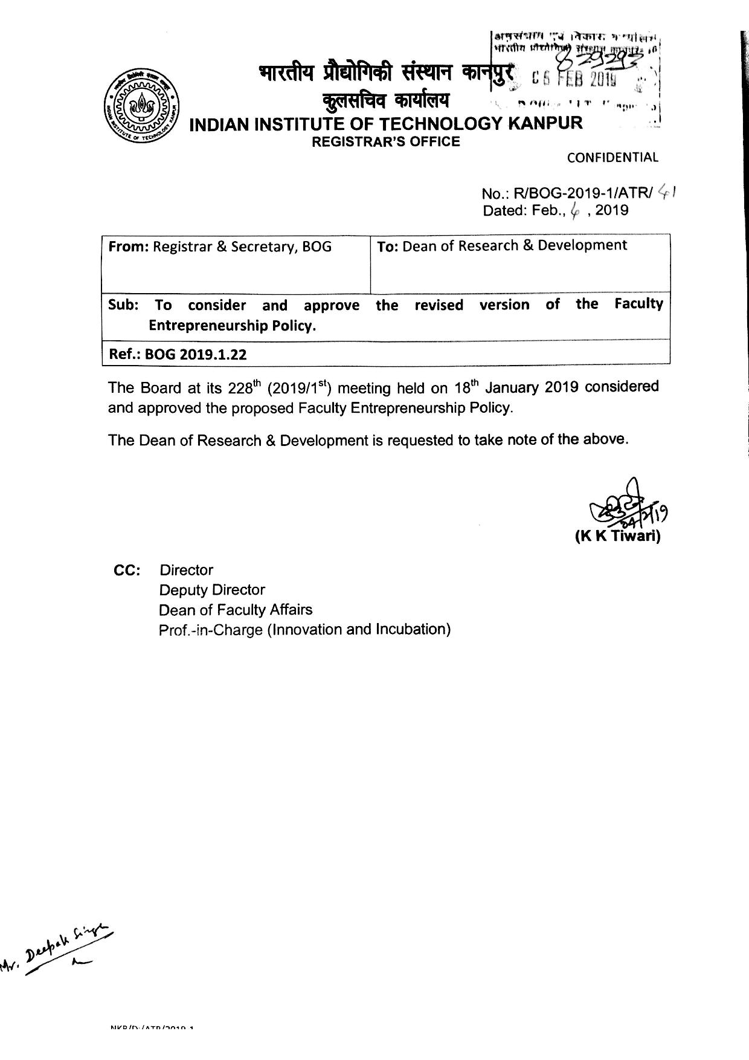
To, Date:- ……………
The Director,
Indian Institute of Technology Kanpur
Kanpur-208016
INDIAN INSTITUTE OF TECHNOLOGY KANPUR
APPLICATION BY THE FACULTY OF IITK, TO ESTABLISH A NEW VENTURE/ENTREPRENERSHIP
A: APPLICANT DETAILS
1. | Name of the Faculty Member
2. | Department :- P.F. Number:-
3. | (a) Email Id:- Mobile No:- Extension No:-
4. | Date of Joining IITK, as Faculty Member
5. | Qualification
6. | Details of the IPRs filed in the name of the Faculty member as Inventor  6(a) Please use the form in Annexure A  6(b) Please list any Know how that you  propose to use for this business, but has  not been secured by any IP prospect.  (please provide details in Annexure C)
7. | Academic information:  - Attach brief CV  - Research summary  - Most significant papers published relevant to the proposed commercial activity (no more than five)
B:-DETAILS OF THE VENTURE TO BE ESTABLISHED
1. | Name/Proposed Name of the Company:
2. | Type of the Company: - ……………………… Profit Making or Non Profit  Note: LLP’s are not allowed Making Company: - ……………………………..  Company, whether existing  Or To be Incorporated: - ………………………….  Proposed date of Incorporation (If already  Existing, then mention the actual date of  Incorporation):- ……………………………………..  Proposed date of Involvement with the  Company, in case of existing Company: - ………………………………
3. | Proposed Members /Shareholders of the Company with % holding | ………………………………
4. | Whether Physical Incubation shall be required | Yes/No:-
5. | Promoters and Directors of the proposed company:  - Names and details (as it appears on RoC documents) of all the Promoters of the Company  - Promoter’s Financial Contribution  - Details (as it appears on RoC documents) of all the members of the Board of Directors of the Company;  - Full Name of Director  - DIN No.  - Contact no  - E mail id  - Nationality  - Interest in other Companies Name of the Company Designation Director/MD /COO/CFO  - Any Foreign Investment?  If Yes (Please provide details)
7. | Proposed role of the Faculty member in the Company  (Whether as Shareholder /Member/Promoter/ Director/Key Executive Capacity etc.)
8 | Please state the number of hours, likely to be dedicated by the Faculty member, in the Enterprise in a week.
9. | Details of the sanctions/Permits/Licenses/ Approvals required from the Government Authorities, if any and the status of the same.
10. | Have you consented to the consideration to be paid to IITK with reference to Faculty Entrepreneurship (if sanctioned), as described in Annexure F
11. | Please accept, attest and attach | The undertaking in regards to Probable Conflict of Interest that may arise during the continuance of the Entrepreneurship in Annexure D
12. | Please attach duly filled Annexure E  It should be noted that grant of permission to incorporate a company is conditional and subject to but not limited to, submission of certified copies of MoA, AoA and certificate of incorporation of the company duly signed and obtained from Registrar of Companies. Such documents should be submitted to IIT Kanpur within SEVEN days from the date of incorporation of the company. | - the drafted memorandum of association & Articles of Association, Bye-Laws of the Enterprise  - the Projected revenues for the next three years  - Last 3 year’s Audited Balance sheet (in case of existing Enterprise)
13. | Have you been associated with any organization, which was associated with IIT Kanpur previously?  If Yes, are there any pending dues associated with the organization towards IIT Kanpur?
14. | Have you ever been part of any other Company as Promoter/Member/Director/?  If Yes, have you ever possessed any DIN (Director Identification Number)?
15. | Any other relevant information, if any

(Name of the Faculty member) | Signature (with date):
Recommended & Forwarded by:  (Name of the HOD) | (Signature of Head of Department)
Recommended & Forwarded by:  (Name of PIC, Innovation & Incubation) | (Signature of PIC, Innovation & Incubation)
Recommended & Forwarded by:  (Name of Dean, R&D) | (Signature of Dean, R&D)
Recommended & Forwarded by:  (Name of Dean, Faculty Affairs) | (Signature of Dean, Faculty Affairs)
Approved by Director IIT Kanpur :-

Annexure –A
IPR Licensing/Assignment request Form
IIT Kanpur
1. | Name of the Faculty Member
2. | Department :- P.F. Number:-
3. | (a) Email Id:- Mobile No:- Extension No:-
4. | Details of the IPRs filed in the name of the Faculty member as Inventor, where IITK is an applicant | - Title of the IPR:  - Application No:
5. | Where IITK is an Applicant
6. | Where IITK is not an Applicant
7. | Is the Faculty member willing to obtain license for any of the Existing IPR’s from IITK, for his prospective Company?  If Yes, please mention the type of Licensing | - Exclusive  - Non-Exclusive  - Assignment of Rights (Fill Annexure – B )

Annexure-B
Relinquishment of IPR’s at IIT Kanpur
Date:

I/We…………..………..…… being true inventors of Patent application titled ……………..…….having IPA No-……………….…. Dated ….………….…, Solemnly relinquish all claims on the above invention on all or any part of the revenue entitled after the technology commercialization, as elaborated in Clause VI of the IP policy of IIT Kanpur.
We also hereby withdraw all our claims as Inventor over the said invention and do not have any objection over transfer of technology or assignment of rights to any third party by IIT Kanpur.

Signature of Authorized Signatory

Annexure- C
List of Knowhow, not secured by any IP prospect

Annexure-D
CONSIDERATION FOR FAUCTLY ENREPRENUERSHIP
- As a consideration for allowing the Faculty member to engage in Entrepreneurship, the Enterprise shall agree to pay to IIT Kanpur, through one of the methods (or combination of methods) mentioned below at the time of signing the FACULTY ENTREPRENEURSHIP AGREEMENT:

10% Non-Dilutable Equity, as upfront consideration to IITK OR a negotiated share of the revenue of the Company OR a combination of non-Dilutable Equity, as upfront consideration AND a negotiated share of the revenue of the Company.
Clarification to the word “Non-Dilutable”
For any period of time in which the Institute owns and/or holds the abovementioned Equity Shares, the Company shall, in the event any of the Promoters of the Company increase or raise their individual shareholding in the Company, whether by issue and/or transfer of any new Equity Shares or otherwise (“Proposed Increase”), grant a right of non-dilution to the Institute; ensuring no dilution to the Equity Shares owned/held by IITK, whereby the Company shall provide to IITK a right to subscribe up-to such number of Equity Shares, calculated on a pro-rate basis, so as to correspondingly increase the amount of Equity Shares held by IITK so that the IITK’s proportionate ownership in the Company, on happening of the Proposed Increase, is not decreased.
- Facilitation Charges-

  - For Research Grant – If the Company applies for a research grant, overhead (10% of the total budget) must be budgeted separately in the grant application. This condition may be relaxed at the sole discretion of Director, IITK.

  - For Consultancy Project or Contractual Service delivery – As a policy, no Company may be incorporated by a faculty member whose only purpose is to provide consultancy service. However, if on occasion a Faculty member incorporated company provides consultancy service then in addition to the considerations stated above, the Company shall pay additional consideration of the amount equivalent to 25% (twenty five) of any consultancy project or contractual service delivery project received by the Company, as part of the assumed alternative to the overheads that could have been earned by the Institute had the project come to the institute due to the efforts of the faculty member.

- Additional consideration, required for any specific Infrastructural services, requested by the Faculty member to be decided on case to case basis mutually.

Annexure-E
Undertaking for Faculty Entrepreneurship
- I undertake to inform the Institute before starting any Company or associating with any enterprise directly or indirectly.

- I undertake that I will take prior permission from the Institute before starting any Company or associating with any enterprise, and will abide by the consideration decided by IIT Kanpur in the form of quantum of equity/fund, as approved by the Institute, on case to case basis.

- I undertake that I will not influence a departmental decision for acquisition of laboratory and/or equipment which could benefit the Company and/or any associated enterprise.

- I undertake that I will not circumvent the prevailing policies for making
use of IITK various facilities for the benefit of the Company and/or any associated enterprise.

- I undertake that I will not take undue advantage of suppliers and service
providers of IITK for the Company and/or any associated enterprise.

- I undertake that I will not procure consultancy assignments or other business in the name
of IIT Kanpur and will not subsequently outsource the same to the Company and/or any associated enterprise.

- I undertake that I will not use students or employees of IIT Kanpur to perform a work for the Company without any compensation and/or approval from the competent authority, when the work is not related in any way to their academic pursuits.

- I undertake that I will not get involved in a decision making process affecting other incubatee companies leading to situation of conflict of interest.

- I undertake that I will submit to the institute modified versions of Articles of Association and Memorandum of Association of the Company, every time such documents are modified and will furnish any information about the Company and/or any associated enterprise as and when required by the Institute.

- I undertake that I will comply with different provisions & government rules & regulations and IIT Kanpur will not be responsible.

- I undertake that I will maintain the Faculty Entrepreneurship policy’s contractual obligations with IIT Kanpur perpetually.

Signature of Applicant:
Date:

Annexure-F

- The drafted memorandum of association & Articles of Association, By Laws of the Enterprise and

- The Projected revenues for the next three years

- Last 3 year’s Audited Balance sheet (in case of existing Enterprise)

