 | Hkkjrh; izkS|ksfxdh laLFkku dkuiqj | 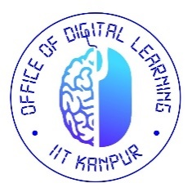
 | INDIAN INSTITUTE OF TECHNOLOGY KANPUR
 | “kSf{kd foHkkXk : dk;kZy;] fMftVy yfuZax
 | ACADEMIC SECTION: OFFICE OF DIGITAL LEARNING
APPLICATION FOR REPEAT/ SUBSTITUTE MODULE(S)
ACADEMIC YEAR:20__ __, QUARTER(Q): ____

Name: ________________________ | Roll no: _________________________ | Programme: ______________________
Department: _________________________ | Email-Id: ________________________
Total Modules Completed (as on date): In Number

MODULES TO REPEAT/SUBSTITUTE
Sl No | Old Module details |  |  |  | Apply for⁺ | New Module Details  (if substituted)
 | Module no. | Module Title | Nature* | Grade |  | Module no. | Module Title
 |  |  | COR/ELE |  | REP/SUB
 |  |  | COR/ELE |  | REP/SUB
 |  |  | COR/ELE |  | REP/SUB
*Please mention COR for Core/Compulsory & ELE for Elective as appropriate.
⁺ Please mention REP for Repeat/ SUB for Substitute as appropriate.

Date: ……………………………. Signature of the candidate

Recommendation of DOPC Convener

Signature of DOPC Convener
FOR OFFICE USE ONLY
Permission for modules to repeat/substitute as detailed above is APPROVED/ NOT APPROVED
Remarks:  Signature of Dealing Assistant | Remarks:  Signature of Chairman, SOPC

